**Interactive Programming in Python -- (RICE University)**

## Week one

**Functions — Functions**

* Functions are reusable pieces of programs that take an input and produce an output.
* A function definition is a compound statement consisting of a header and a body.
* The header includes the keyword def, a sequence of parameters enclosed by parentheses, followed by a colon :.
* The body consists of a sequence of statements, all indented by 4 spaces.
* Functions may return a value using the keyword return or have a side effect (e.g., print).
* To evaluate a function call, replace the function's parameters in the body of the function by their associated values in the call and execute the body of the function.
* Lecture examples - [Functions](http://www.codeskulptor.org/#examples-functions.py)
* More examples - [Stucture of Functions](http://www.codeskulptor.org/#examples-more-1b_functions-structure.py), [Uses of Functions](http://www.codeskulptor.org/#examples-more-1b_functions-uses.py), [Scope of Variables](http://www.codeskulptor.org/#examples-more-1b_functions-scope.py), [Examples of Functions](http://www.codeskulptor.org/#examples-more-1b_functions-examples.py)

**Indentation — Functions**

* Indentation consists of whitespace formed by blanks, tabs, and newlines.
* Leading white space indicates indentation level (4 spaces per level) and specifies logical grouping of statements in Python.
* Incorrect indentation can lead to errors.
* Lecture examples - [Functions](http://www.codeskulptor.org/#examples-functions.py)
* More examples - [Function Errors](http://www.codeskulptor.org/#examples-more-1b_functions-errors.py)

**Remainders and modular arithmetic — More Operations**

* Standard long division yields a quotient and a remainder. The integer division operator // computes the quotient. The operator % computes the remainder.
* For any integers a and b, a == b * (a // b) + (a % b).
* In Python, a % b always returns an answer that is between 0 and b (even if a and/or b is negative).
* Remainders and modular arithmetic are very useful in games for the purpose of "wrapping" the canvas, i.e; causing objects that pass off of one side of the canvas to reappear on the opposite side of the canvas.
* Lecture examples - [More operations](http://www.codeskulptor.org/#examples-more_operations.py)
* More examples - [Modulus](http://www.codeskulptor.org/#examples-more-1b_more_operations-modulus.py), [Math Module](http://www.codeskulptor.org/#examples-more-1b_more_operations-math_module.py),

**Modules — More Operations**

* Modules are libraries of Python code that implement useful operations not included in basic Python.
* Modules can be accessed via the import statement.
* CodeSkulptor implements parts of the standard Python modules math and random.
* Lecture examples - [More operations](http://www.codeskulptor.org/#examples-more_operations.py)
* More examples - [Math Module](http://www.codeskulptor.org/#examples-more-1b_more_operations-math_module.py), [Numbers and Strings](http://www.codeskulptor.org/#examples-more-1b_more_operations-numbers_and_strings.py), [Random Module](http://www.codeskulptor.org/#examples-more-1b_more_operations-random_module.py), [Module Errors](http://www.codeskulptor.org/#examples-more-1b_more_operations-errors.py)

**Boolean Expressions — Logic and Comparisons**

* The constants True and False of the type bool.
* These constants can be combined to form Boolean expressions via the logical operators and, or, and not.
* The and of two Boolean expressions is True if both of the expressions are True.
* The or of two Boolean expressions is True if at least one of the expressions is True.
* Lecture examples - None
* More examples - [Booleans](http://www.codeskulptor.org/#examples-more-1b_logic_and_comparisons-booleans.py), [Boolean Logic](http://www.codeskulptor.org/#examples-more-1b_logic_and_comparisons-logic.py)

**Relational Operators — Logic and Comparisons**

* The values of two arithmetic expressions can be compared using the operators ==, !=, <, >, <=, >=.
* These comparisons return either True or False .
* Lecture examples - None
* More examples - [Comparison](http://www.codeskulptor.org/#examples-more-1b_logic_and_comparisons-comparison.py), [Boolean Expressions](http://www.codeskulptor.org/#examples-more-1b_logic_and_comparisons-expressions.py)

**Conditional Statements — Conditionals**

* Conditional statements are compound statements consisting one or more clauses headed by the keywords if, elif, and else.
* Each if or elif clause is followed by a Boolean expression and a colon :.
* If the Boolean expression for a clause is True, the body of the clause is executed.
* Lecture examples - [Conditionals](http://www.codeskulptor.org/#examples-conditionals.py)
* More examples - [if-elif-else](http://www.codeskulptor.org/#examples-more-1b_conditionals-if-elif-else.py), [Examples of Conditionals](http://www.codeskulptor.org/#examples-more-1b_conditionals-examples.py)

**Programming Tips —** [**Week 1**](http://www.codeskulptor.org/#examples-tips1.py)

**Week1 -- Lecture 1 -- Functions**

<http://www.codeskulptor.org/#examples-functions.py>

Functions 🡪 We can type code ones and use it (call it) many times.

Return -- is an output of this function.

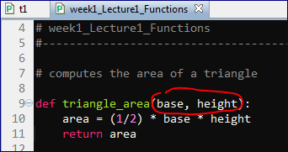

We use "base" and "height" just inside the function.

If a Python function contains no return statements, what value does the function return?

It returns **None**

colon :

indentation

return

**Lecture 3**

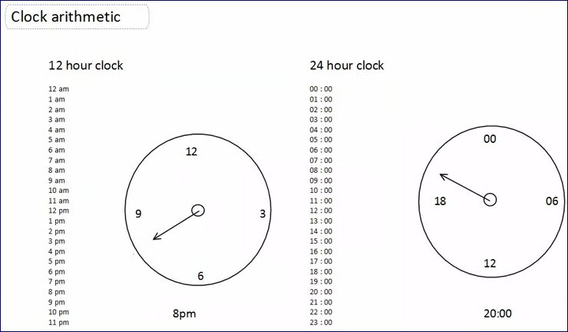

## Week two

**Event handlers — Event-driven programming**

* Event handlers (also called callbacks) are functions registered to an event such as a button click, keyboard press or mouse click.
* Event handlers react to the event by changing the state (collection of information) encoded in the program.
* Lecture examples - [Events](http://www.codeskulptor.org/#examples-events.py)
* More examples - None

**Local variables — Local vs. global variables**

* Assignment to a variable inside a Python function creates a local variable.
* The scope of variable (portion of the program where the value of the variable can be accessed) is the body of function.
* Lecture examples - [Local vs Global](http://www.codeskulptor.org/#examples-local_vs_global.py)
* More examples - [Example](http://www.codeskulptor.org/#examples-more-2a_local_vs_global-example.py)

**Global variables — Local vs. global variables**

* Variables defined outside functions are global variables. Their values may be accessed inside functions without declaration.
* To modify to a global variable inside a function, the variable must be declared inside the function using the keyword global.
* Global variables are a convenient (but dangerous) way for event handlers to share information in event-driven programming.
* Lecture examples - [Local vs Global](http://www.codeskulptor.org/#examples-local_vs_global.py)
* More examples - [Example](http://www.codeskulptor.org/#examples-more-2a_local_vs_global-example.py)

**SimpleGUI module — SimpleGUI**

* Special module for CodeSkulptor that supports 2D interactive applications. The Docs button links to documentation for SimpleGUI.
* SimpleGUI allows creations of frames and timers as well as loading sounds and images.
* Frames include a control panel (with buttons and input fields), a status area (for monitoring keyboard and mouse events) and a canvas (with simple 2D drawing operations).
* Lecture examples - [SimpleGUI](http://www.codeskulptor.org/#examples-simplegui-0.py), [Template](http://www.codeskulptor.org/#examples-simplegui-1.py)
* More examples - [Layout](http://www.codeskulptor.org/#examples-more-2a_simplegui-layout.py), [Frame](http://www.codeskulptor.org/#examples-more-2a_simplegui-frame.py), [Errors](http://www.codeskulptor.org/#examples-more-2a_simplegui-errors.py)

**Buttons — Buttons**

* Buttons may be created (and their event handlers registered) via add_button.
* Buttons are positioned linearly (top/down) in the control panel in their order of creation.
* Lecture examples - [Calculator](http://www.codeskulptor.org/#examples-calculator-0.py), [Buttons](http://www.codeskulptor.org/#examples-buttons.py)
* More examples - [Structure](http://www.codeskulptor.org/#examples-more-2b_buttons-structure.py), [Canvas Color](http://www.codeskulptor.org/#examples-more-2b_buttons-canvas_color.py), [Prize Boxes](http://www.codeskulptor.org/#examples-more-2b_buttons-prize_boxes.py), [True-False Quiz](http://www.codeskulptor.org/#examples-more-2b_buttons-true_false_quiz.py)

**Input fields — Input fields**

* Input fields may be created (and their event handlers registered) via add_input.
* Input fields are positioned linearly (top/down) in the control panel in their order of creation.
* The event handlers for the input field take a single parameter that is the text string entered.
* Lecture examples - [Calculator](http://www.codeskulptor.org/#examples-calculator-1.py), [Input Fields](http://www.codeskulptor.org/#examples-input_fields.py)
* More examples - [Structure](http://www.codeskulptor.org/#examples-more-2b_input_fields-structure.py), [Functions](http://www.codeskulptor.org/#examples-more-2b_input_fields-functions.py), [Factoring](http://www.codeskulptor.org/#examples-more-2b_input_fields-factoring.py), [Silly Words](http://www.codeskulptor.org/#examples-more-2b_input_fields-silly_words.py)

**Programming Tips —** [**Week 2**](http://www.codeskulptor.org/#examples-tips2.py)

Event Driven programs

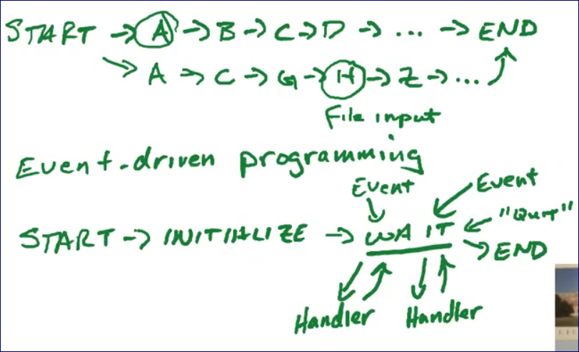

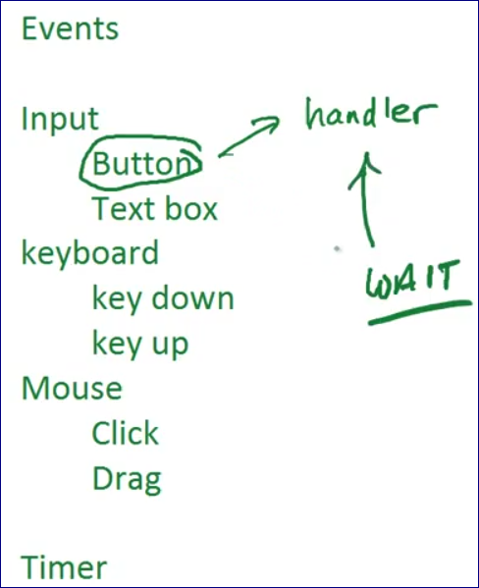

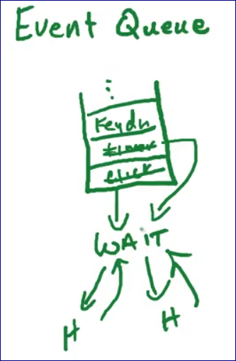

**Local vs. global variables (11:23)**

Anytime you define a variable outside of the function you build a GLOBAL variable.

Variables inside functions are LOCAL.

You cannot access LOCAL variables after the function was called.

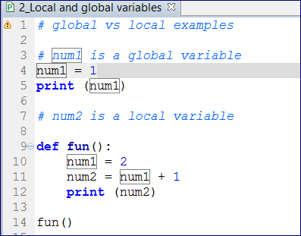

We can explicitly define a variable in the function to be GLOBAL.

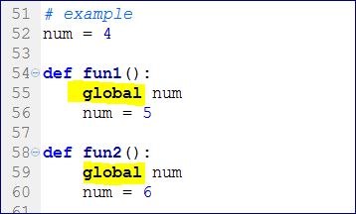

**SimpleGUI (11:27)**

*# 1. Import the module*

**import** simplegui

*# 2. Define global variables (program state)*

*# 3. Define "helper" functions*

*# 4. Define event handler functions*

*# 5. Create a frame*

*# 6. Register event handlers*

*# 7. Start frame and timers*

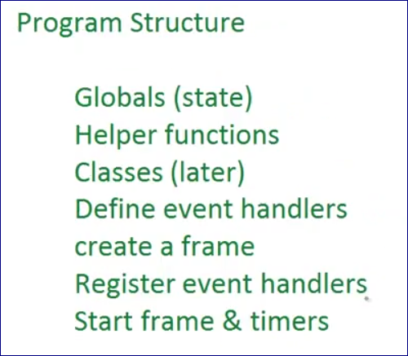

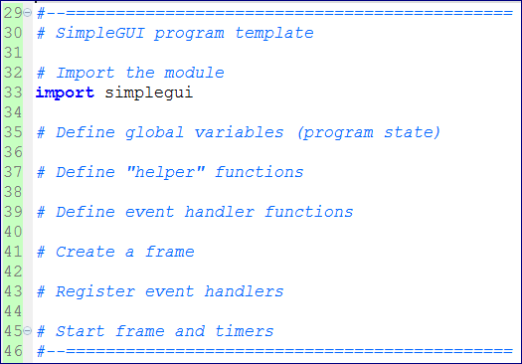

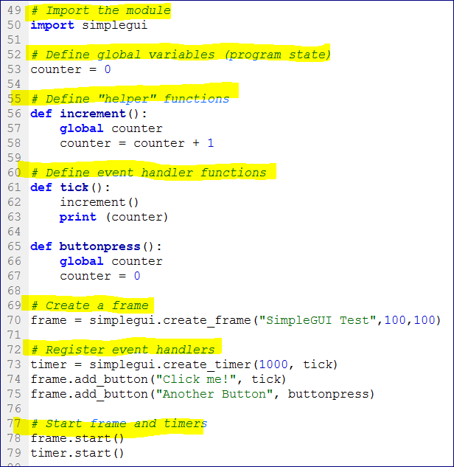

**Buttons (10:48)**

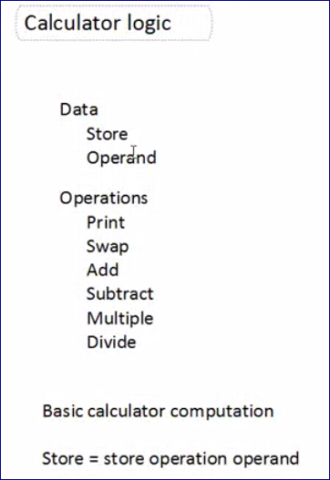

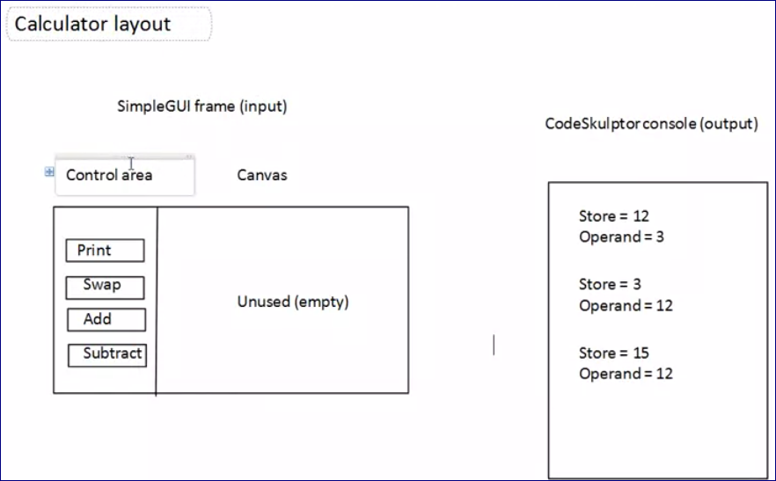

**Week2**

**Input fields (9:34)**

<http://www.codeskulptor.org/#examples-input_fields.py>

**Programming Tips2**

<http://www.codeskulptor.org/#user11_ncGzO2TZUC_1.py>

## Week three

**Canvas** — Canvas and drawing

* The canvas is the area associated with an application where information contain in the application may be drawn.
* In SimpleGUI applications, the width and height of the canvas are specified (in pixels) in create_frame. (A pixel is the smallest unit of area that your computer can draw in.)
* The origin for the canvas is the upper left-hand corner.
* Positions in the canvas are specified as pairs [x,y] where x is the horizontal coordinate and y is the vertical coordinate.
* Lecture examples - [Canvas and Drawing](http://www.codeskulptor.org/#examples-canvas_and_drawing.py)
* More examples - [Structure](http://www.codeskulptor.org/#examples-more-3a_canvas_and_drawing-structure.py)

**Event-driven drawing** — Canvas and drawing

* Computers refresh their screens around 60 times per sec.
* For each application, the computer calls a special event handler, the draw handler, that is registered to the application.
* In SimpleGUI, the draw handler is registered via set_draw_handler.
* The draw handler can modify the canvas via simple draw operations defined in SimplGUI
* Lecture examples - [Canvas and Drawing](http://www.codeskulptor.org/#examples-canvas_and_drawing.py)
* More examples - [Structure](http://www.codeskulptor.org/#examples-more-3a_canvas_and_drawing-structure.py), [Echo](http://www.codeskulptor.org/#examples-more-3a_canvas_and_drawing-echo.py)

**String operations** — String processing

* The function str converts other types of data into a string.
* The concatenation operator + joins two strings to form a single string,
* The ith element of a string my_string can be access via my_string[i]. Note that strings are immutable (cannot be changed).
* Substrings of my_string can be accessed via slicing .
* Lecture examples - [Strings](http://www.codeskulptor.org/#examples-strings-0.py), [Dollars and Cents One](http://www.codeskulptor.org/#examples-strings-1.py), [Dollars and Cents Two](http://www.codeskulptor.org/#examples-strings-2.py)
* More examples - [Operations](http://www.codeskulptor.org/#examples-more-3a_string_processing-operations.py), [Input Checking](http://www.codeskulptor.org/#examples-more-3a_string_processing-input_checking.py), [Initials](http://www.codeskulptor.org/#examples-more-3a_string_processing-initials.py)

**Drawing text** — Interactive drawing

* The method draw_text draws a string when given a position (lower left corner), a font size and a color.
* The method draw_circle (see "More examples" below) draws a circle at a given point with a given radius in pixels. To draw a point, draw a circle of radius one.
* The method draw_line (see "More examples" below) draws a line between two points.
* The method draw_polygon (see "More examples" below) draws a sequence of points (enclosed in square brackets and separated by commas) as a closed polygon.
* Colors for drawing methods can be specified as HTML color strings; "White", "Red", "Green", ...
* Lecture examples - [Interactive Drawing](http://www.codeskulptor.org/#examples-interactive_drawing.py)
* More examples - [Shapes](http://www.codeskulptor.org/#examples-more-3a_interactive_drawing-shapes.py), [Pictures](http://www.codeskulptor.org/#examples-more-3a_interactive_drawing-pictures.py), [Hidden Picture](http://www.codeskulptor.org/#examples-more-3a_interactive_drawing-hidden_picture.py)

**Timers** — Timers

* Timers are another component of SimpleGUI that generate regularly timed events.
* Users create a timer using create_timer with a specified interval and event handler.
* The timer calls its associated event handler regularly at the given interval.
* A timer t is started with t.start() and is stopped by t.stop().
* Lecture examples - [Timers](http://www.codeskulptor.org/#examples-timers.py)
* More examples - [Blinking Text](http://www.codeskulptor.org/#examples-more-3b_timers-blinking_text.py), [Reaction Time](http://www.codeskulptor.org/#examples-more-3b_timers-reaction_time.py)

**Programming Tips** — [Week 3 (pt. 1)](http://www.codeskulptor.org/#examples-tips3-events.py), [Week 3 (pt. 2)](http://www.codeskulptor.org/#examples-tips3.py)

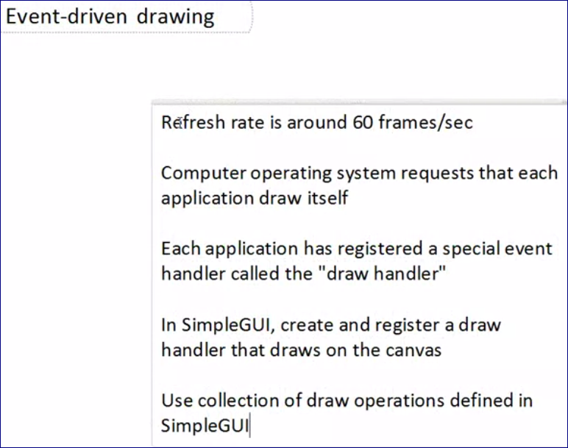

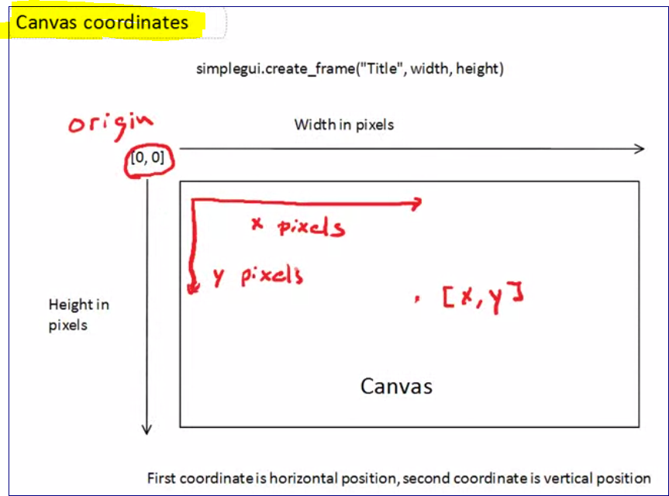

<http://www.codeskulptor.org/#examples-canvas_and_drawing.py>

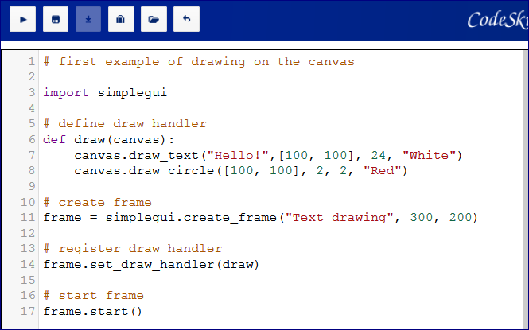

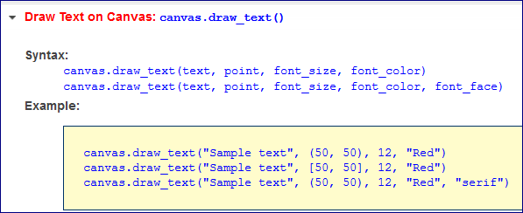

<http://www.codeskulptor.org/#user12_AFHheYJMs1_0.py>

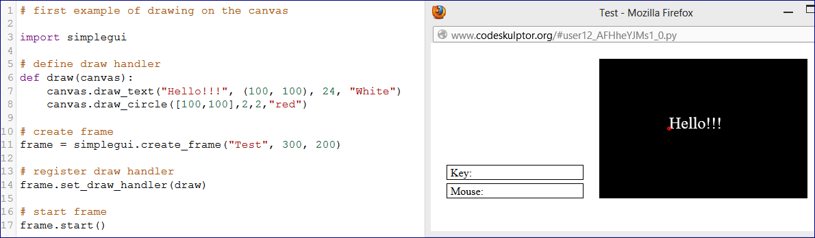

<http://www.codeskulptor.org/#examples-drawing.py>

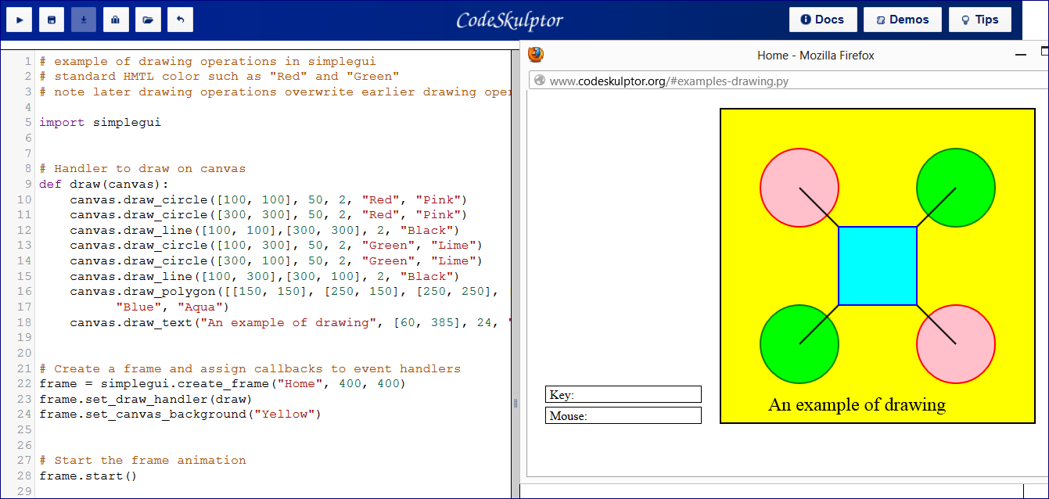

**week3 -- String processing (11:46)**

<http://www.codeskulptor.org/#examples-strings.py>

<http://www.codeskulptor.org/#user12_eA3JHgpj21_3.py>

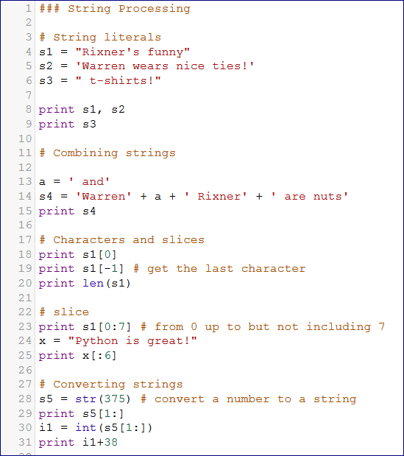

<http://www.codeskulptor.org/#examples-money-0.py>

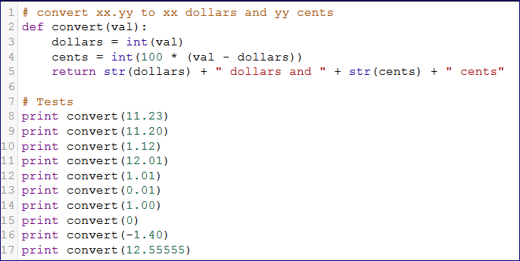

<http://www.codeskulptor.org/#examples-money-1.py>

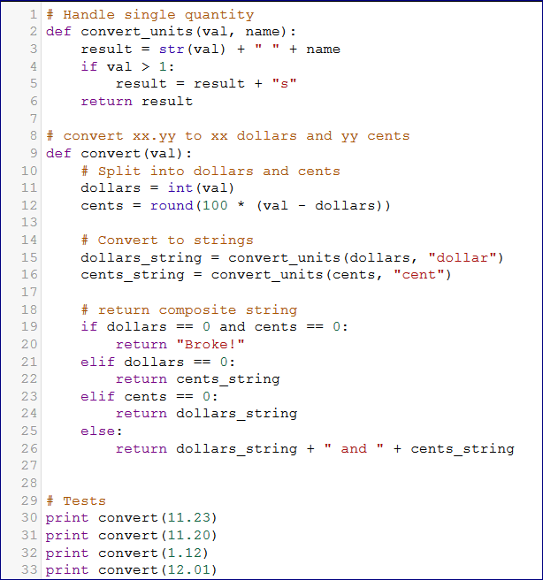

<http://www.codeskulptor.org/#user12_PTIt3HvIDr_5.py>

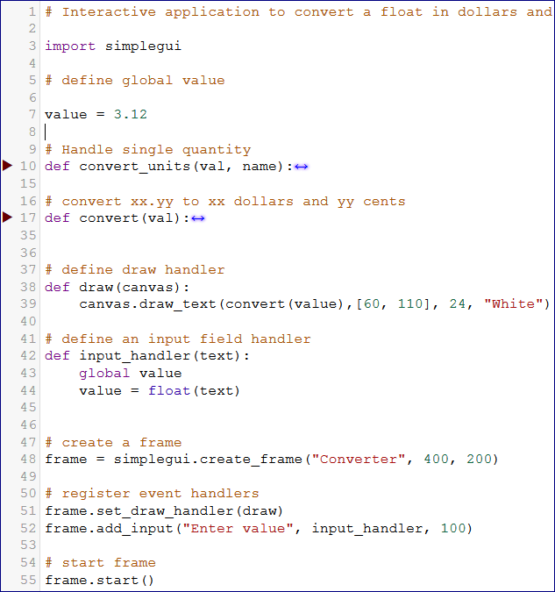

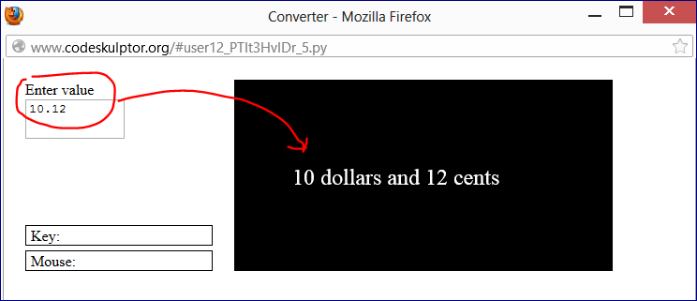

**week3 -- Timers (9:58)**

<http://www.codeskulptor.org/#examples-timers.py>

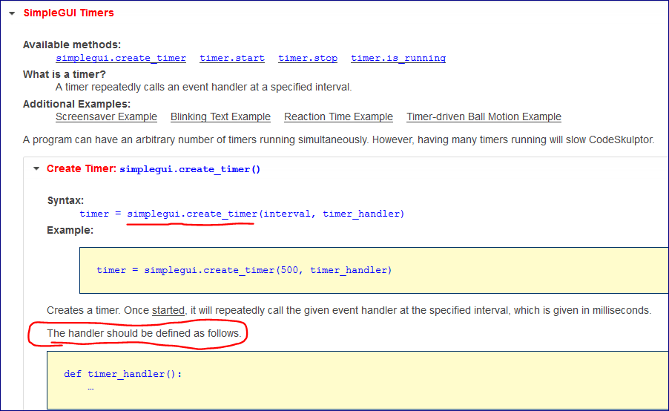

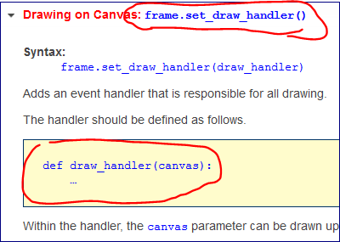

<http://www.codeskulptor.org/#examples-timers.py>

<http://www.codeskulptor.org/#user12_PTIt3HvIDr_11.py>

# Simple "screensaver" program.

import simplegui

import random

# Global state

message = "Python is Fun!"

position = [50, 50]

width = 500

height = 500

interval = 2000

# Handler for text box

def myTextHandler(text):

global message

message = text

# Handler for timer

def myTimeHandler():

x = random.randrange(0, width)

y = random.randrange(0, height)

position[0] = x

position[1] = y

# Handler to draw on canvas

def myHandler(holst):

holst.draw_text(message, position, 36, "Red")

# Create a frame

frame = simplegui.create_frame("Screensaver", 300, 300)

# Register event handlers

frame.set_draw_handler(myHandler)

timer = simplegui.create_timer(interval, myTimeHandler)

frame.add_input("Message: ", myTextHandler, 200)

# Start the frame animation

frame.start()

timer.start()

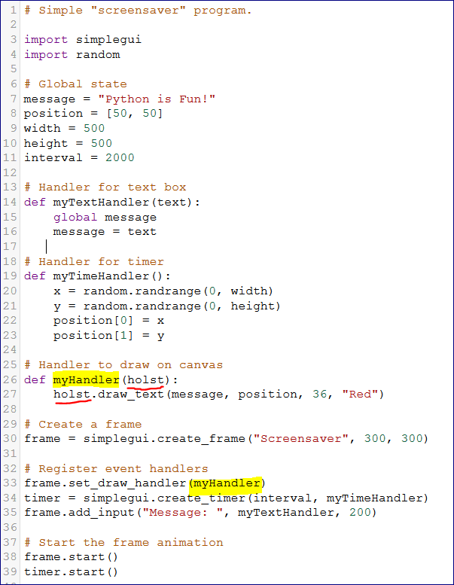

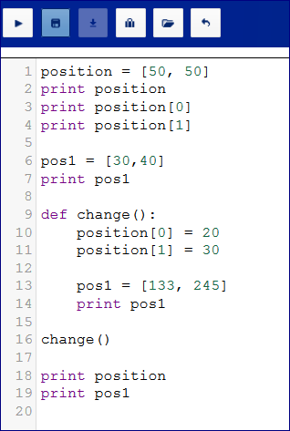

**week3 -- Programming tips - 3 (7:10)**

<http://www.codeskulptor.org/#user12_2TdT7abMpz_2.py>

<http://www.codeskulptor.org/#user12_2TdT7abMpz_3.py>

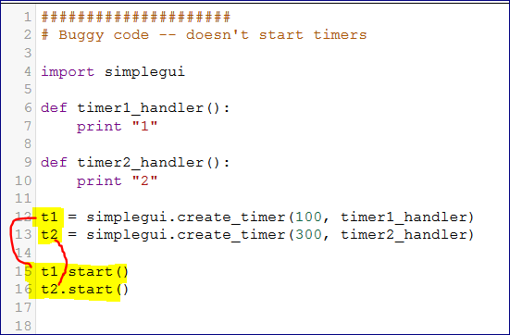

<http://www.codeskulptor.org/#user12_sSArxqhCF2_0.py>

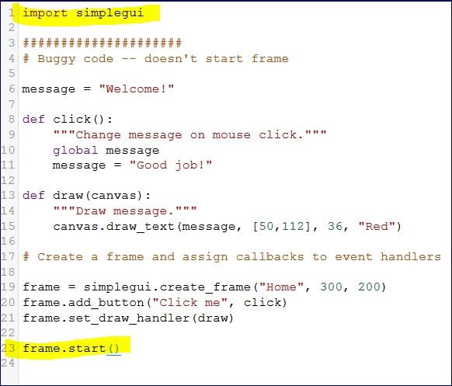

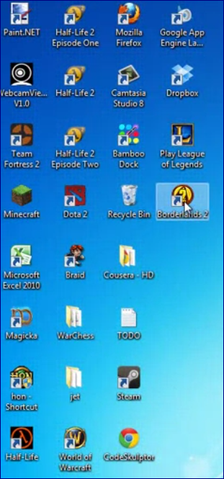

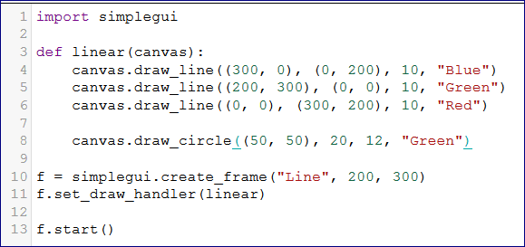

**Week 4a - Basics of lists**

## Week four

**Lists — Lists**

* Lists can be constructed as a sequence of objects inside square brackets; e.g; [2,4,6]. The list function also converts other types of sequence data such as strings into lists.
* Sequence operations such as indexing l[i], concatenation +, length len(l) and slicing apply to lists.
* As opposed to strings, an element of a list can be mutated via assignment l[i] = x.
* Lecture examples - None
* More examples - [Structure](http://www.codeskulptor.org/#examples-more-4a_lists-structure.py), [Tuples](http://www.codeskulptor.org/#examples-more-4a_lists-tuples.py), [True-False Quiz](http://www.codeskulptor.org/#examples-more-4a_lists-true_false_quiz.py), [Silly Words](http://www.codeskulptor.org/#examples-more-4a_lists-silly_words.py), [Rainbow Canvas](http://www.codeskulptor.org/#examples-more-4a_lists-rainbow_canvas.py), [Digital Numbers](http://www.codeskulptor.org/#examples-more-4a_lists-digital_numbers.py)

**Points and vectors — Motion**

* A point in 2D is represented by a pair of Cartesian coordinates.
* A vector in 2D is represented by a pair of numbers (its horizontal and vertical components).
* Taking the difference of two points (componentwise) yields a vector.
* Vectors can be added and scaled (componentwise). Points should not be added or scaled.
* Adding a point and a vector (componentwise) yields a new point. This operation can be used to animate moving points.
* Lecture examples - [Timer Control](http://www.codeskulptor.org/#examples-motion_explicit.py), [Formula Control](http://www.codeskulptor.org/#examples-motion_implicit.py)
* More examples - [Drawing Vectors](http://www.codeskulptor.org/#examples-more-4a-motion-drawing_vectors.py)

**Distance computations — Collisions and reflections**

* The distance between two points p0 and p1 is   
  √(p0[0]-p1[0])2+(p0[1]-p1[1])2 .
* The distance between a point and a circle and the distance between two circles follows from this formula.
* The set of points [x,y] that satisfy the equation a*x + b*y + c == 0 is a line. The distance from this line to a point p is   
  (a*p[0] + b*p[1] + c)/ √a2 + b2
* The distance from a circle to a line is the distance from the center of the circle to the line minus the radius.
* Lecture examples - [Timer Control](http://www.codeskulptor.org/#examples-collisions_and_reflections.py)
* More examples - [Drawing Vectors](http://www.codeskulptor.org/#examples-more-4a-motion-drawing_vectors.py)

**Reflections — Collisions and reflections**

* The direction of reflection for a ball bouncing off of a wall depends on the incoming velocity vector v and the normal vector to the wall at the point of contact.
* The incoming velocity vector can be decomposed into v = vp + vn where vn is the component of v orthogonal to wall and vp is the component parallel to to the wall.
* In this model, the reflected vector is v = vp - vn.
* This model simplifies for horizontal and vertical walls. In particular, reflection simply negates one component of the velocity vector v.
* Lecture examples - [Timer Control](http://www.codeskulptor.org/#examples-collisions_and_reflections.py)
* More examples - None

**Keyboard events — Keyboard input**

* SimpleGUI suppports two event handlers for keyboard events.
* The key down event handler is registered via set_keydown_handler.
* The key up event handler is registered via set_keyup_handler.
* The variable passed to each of these handlers is a number that can be compared at the constants in KEY_MAP to determine which key has been pressed.
* Lecture examples - [Echo](http://www.codeskulptor.org/#examples-keyboard-0.py)
* More examples - [Shape Selection](http://www.codeskulptor.org/#examples-more-4a_keyboard_input-shape_selection.py)

**Positional control — Keyboard input**

* We can control the position of a point p directly using key board events.
* The horizontal and vertical components of a point p's position can be increment/decrement via p[i] += c in response to key presses.
* Lecture examples - [Ball Position](http://www.codeskulptor.org/#examples-keyboard-1.py)
* More examples - None

**Velocity control — Velocity control**

* Basic physics relates the position of a point p and its velocity v via the equation p += dt * v where dt is a small time step.
* In this model, we can control the motion of p via keyup/keydown events that increment/decrement the two components of the velocity vector v via v[i] += c.
* Lecture examples - [Velocity Control](http://www.codeskulptor.org/#examples-velocity_control.py)
* More examples - [Ball Track](http://www.codeskulptor.org/#examples-more-4b_velocity_control-ball_track.py)

**Mutable vs. immutable data — Programming tips #4**

* Numbers, Booleans and strings are immutable and can not be modified. Only new copies of these kinds of data can be made.
* On the other hand, parts of a list can be mutated via assignment to individual elements of the list.
* Assignment of an entire list to a variable generates a reference that refers to the list. Subsequent assignment may generate multiple references to the same list.
* Mutating a list with multiple references modifies all references to the list. This capability is very useful, but can generate subtle errors.
* Lecture examples - [Global](http://www.codeskulptor.org/#examples-tips4-global.py), [Tuples](http://www.codeskulptor.org/#examples-tips4-tuples.py)
* More examples - [List Structure](http://www.codeskulptor.org/#examples-more-4a_lists-structure.py)

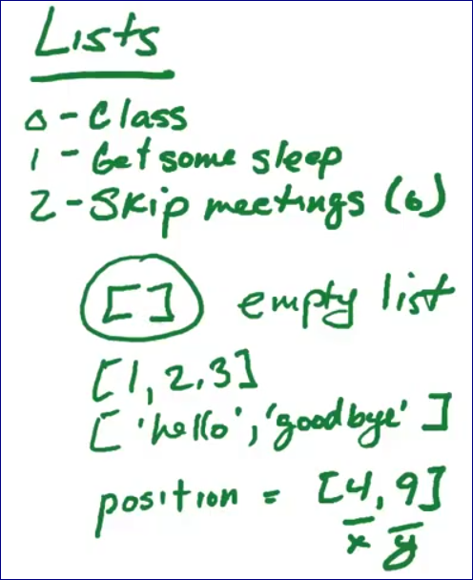

<http://www.codeskulptor.org/#user13_lAyz1hGZZu_2.py>

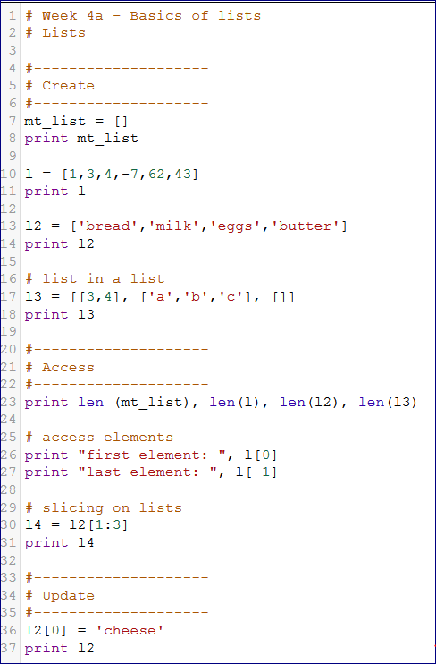

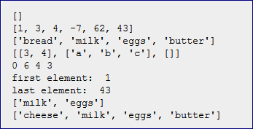

**Keyboard input (9:25)**

<http://www.codeskulptor.org/#examples-keyboard_echo.py>

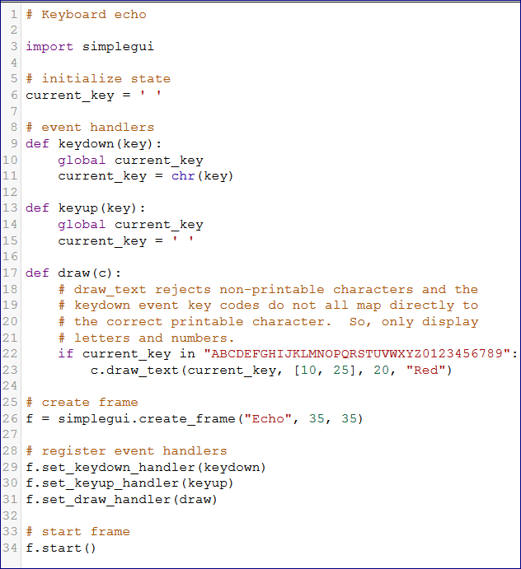

<http://www.codeskulptor.org/#examples-position_control.py>

<http://www.codeskulptor.org/#user13_TAqhRIy9oG_2.py>

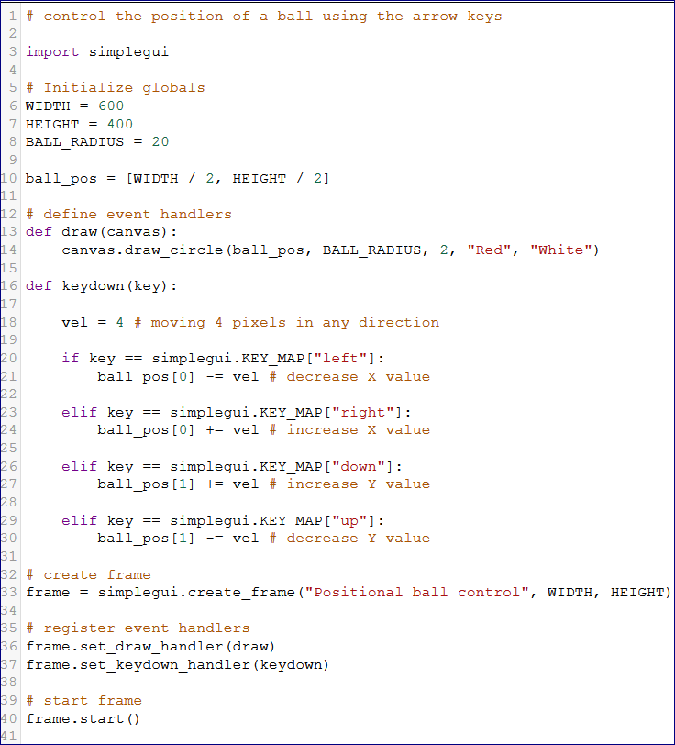

**Motion (14:01)**

<http://www.codeskulptor.org/#examples-motion_explicit.py>

Adding a vector to a point

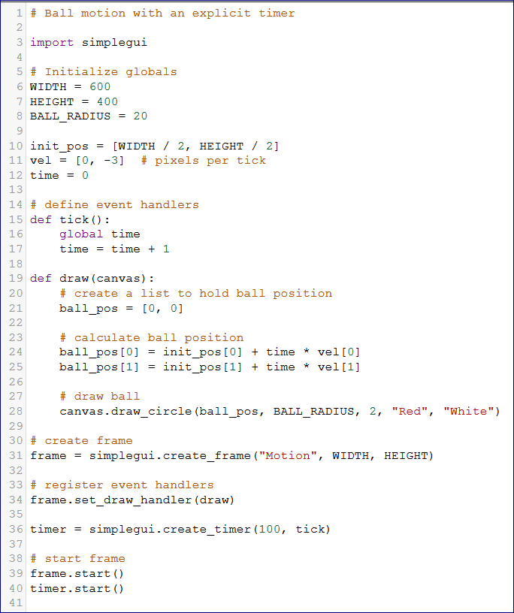

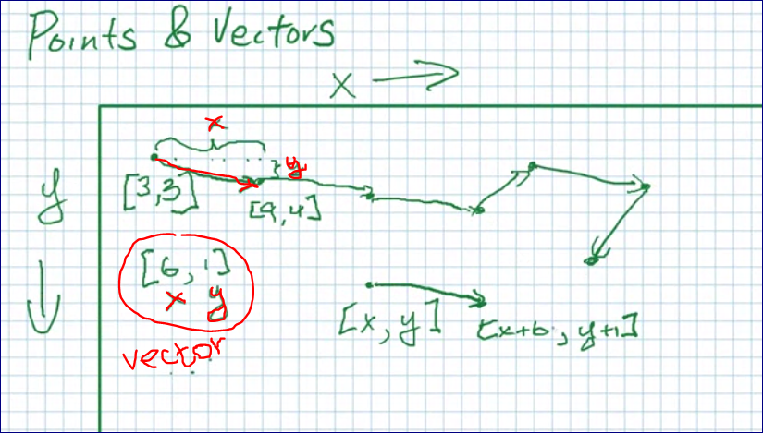

Position = P * V

P(t) -- position

V(t) -- velocity (скорость)

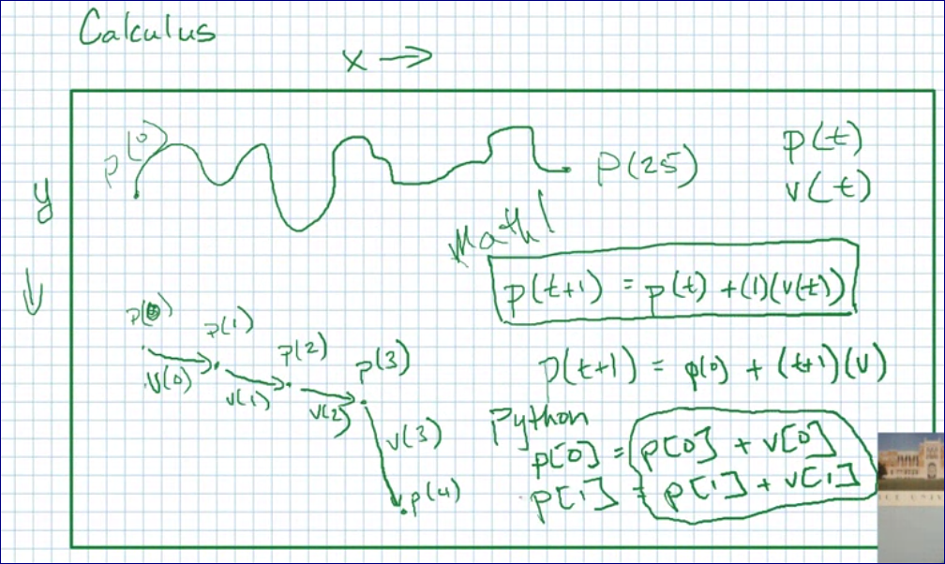

<http://www.codeskulptor.org/#examples-motion_implicit.py>

We remove timer and initial position.

Now to change a speed we have to change a velocity vector.

It updates every 1/60 seconds.

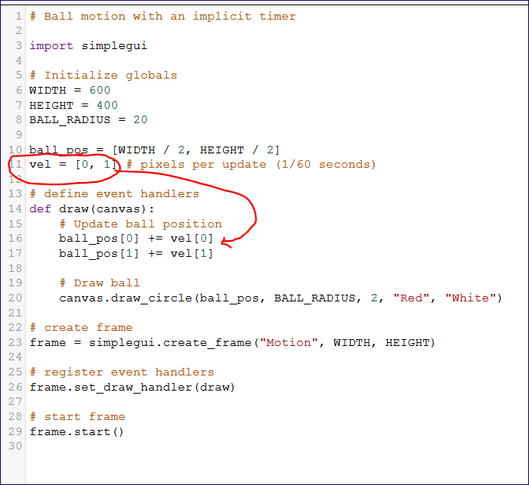

**Collisions and reflections (12:09)**

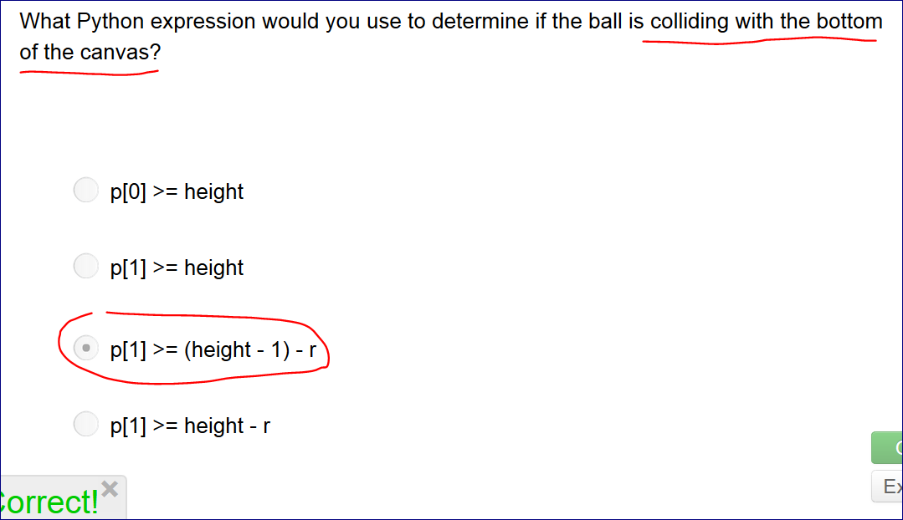

Reflect a ball from the wall

<http://www.codeskulptor.org/#examples-collisions_and_reflections.py>

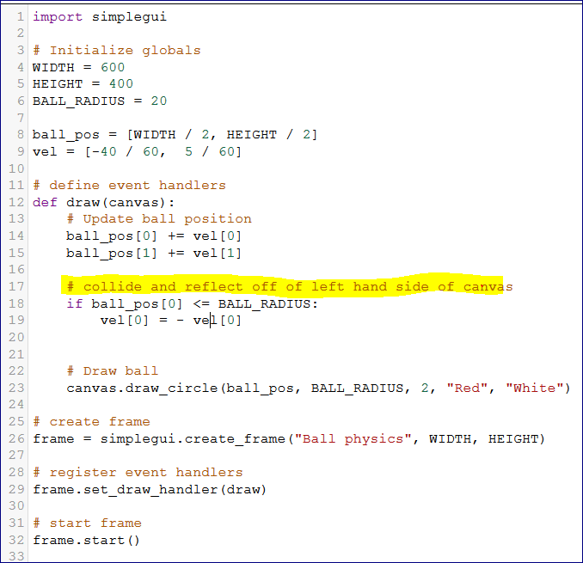

<http://www.codeskulptor.org/#user13_ZyINIeV8zY_2.py>

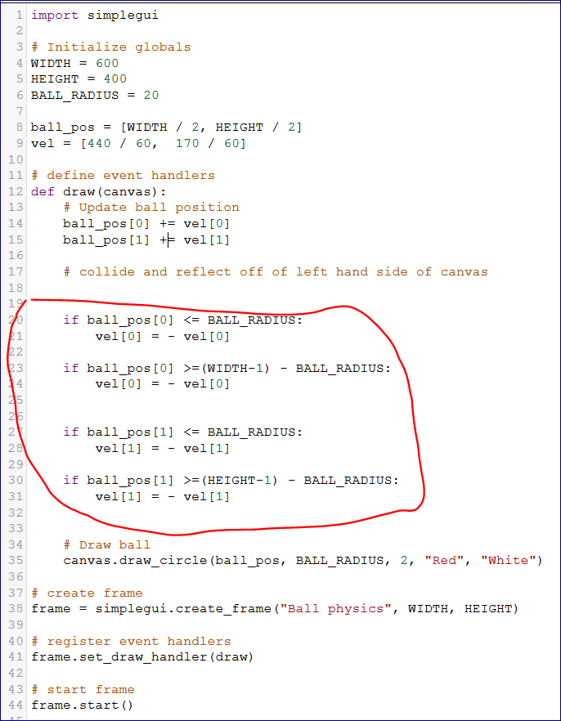

**Velocity control (9:22)**

<http://www.codeskulptor.org/#user13_vydH3WghTF_1.py>

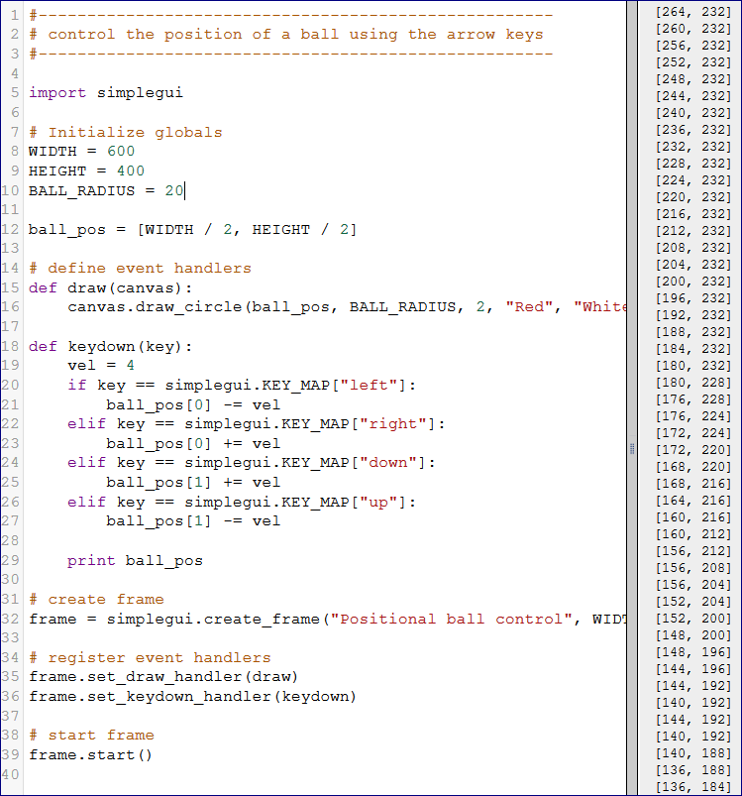

<http://www.codeskulptor.org/#user13_ZhXoZXpMWh_2.py>

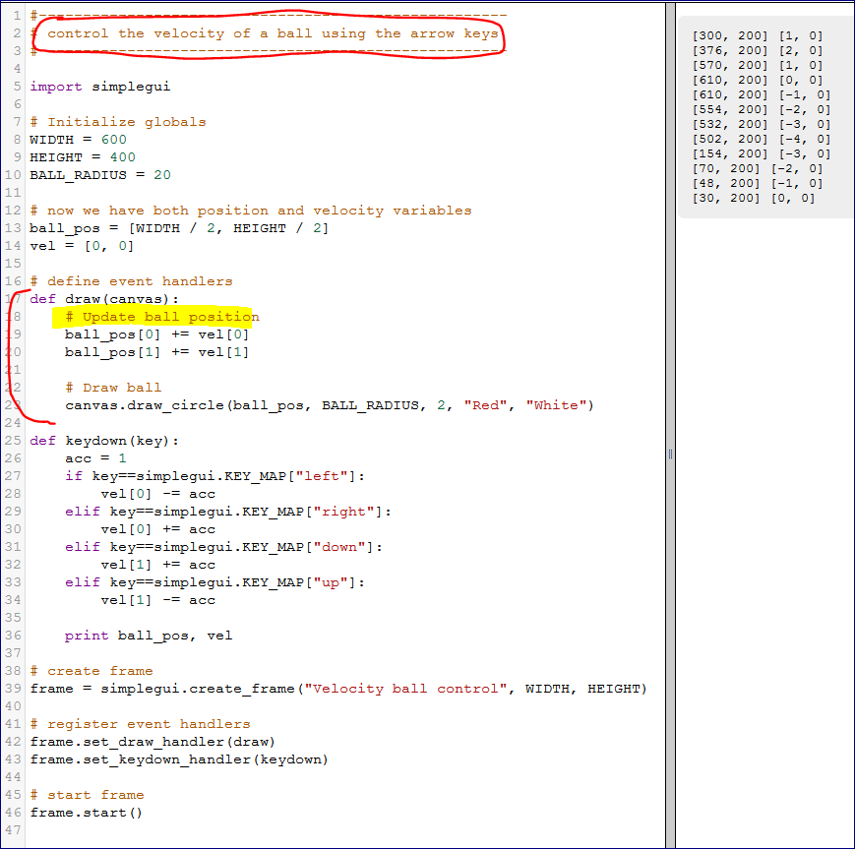

**Programming tips - 4 (9:35)**

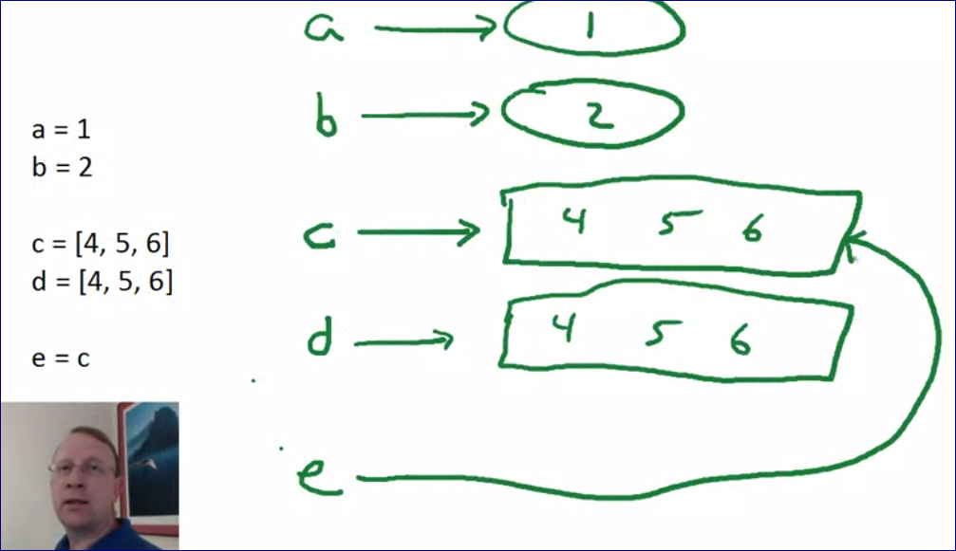

This is not assignment -- **this is mutation** -- we are changing "a".

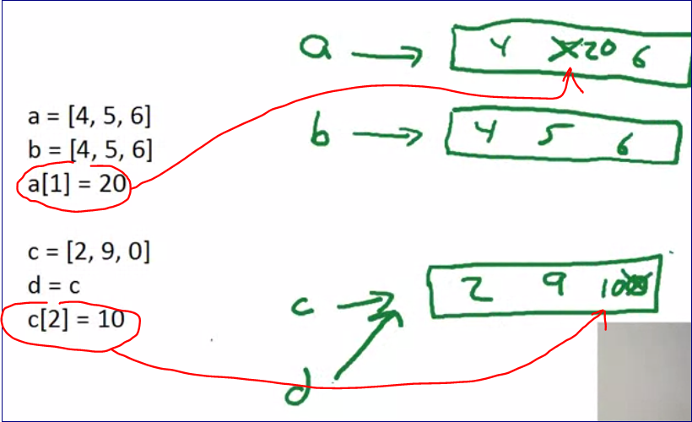

**Lists are mutable and Tuples are Not mutable**

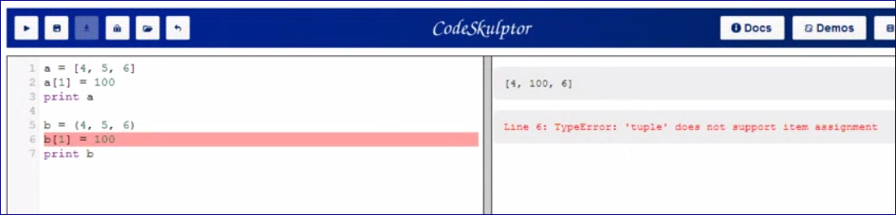

###################################

# Mutation vs. assignment

################

# Look alike, but different

a = [4, 5, 6]

b = [4, 5, 6]

print "Original a and b:", a, b

a[1] = 20

print "New a and b:", a, b

################

# Aliased

c = [2, 9, 0]

d = c

print "Original c and d:", c, d

c[2] = 10

print "New c and d:", c, d

################

# Copied

e = ["a", "b", "c"]

f = list(e)

print "Original e and f:", e, f

e[0] = "z"

print "New e and f:", e, f

###################################

# Interaction with globals

a = [4, 5, 6]

def modify_part(x):

"""Change part of global a to be x."""

a[0] = x

def modify_whole(x):

"""Change global a to be x."""

a = x

modify_part(100)

print a

modify_whole(100)

print a

###################################

# Lists (mutable) vs. tuples (immutable)

print [4, 5, 6]

print (4, 5, 6)

print type([4, 5, 6])

print type((4, 5, 6))

a = [4, 5, 6]

a[1] = 100

print a

b = (4, 5, 6)

b[1] = 100

print b

**--====================================================================**

## Week five

**Mouse events** — Mouse input

* SimpleGUI suppports two event handlers for mouse events.
* The mouse clicked event handler is triggered when the mouse is clicked. The handler is registered via set_mouseclick_handler.
* The mouse dragged event handler is triggered when the mouse is clicked and dragged. This handler is registered via set_mousedragged_handler.
* The variable passed to each of these handlers is the position of the mouse in canvas coordinates when the event is triggered.
* Lecture examples - [Mouse Input](http://www.codeskulptor.org/#examples-mouse_input.py)
* More examples - [Ball Movement](http://www.codeskulptor.org/#examples-more-5_mouseclick_handlers-ball_movement.py), [Click Lines](http://www.codeskulptor.org/#examples-more-5_mouseclick_handlers-click_lines.py), [Tic-Tac-Toe](http://www.codeskulptor.org/#examples-more-5_mouseclick_handlers-tic_tac_toe.py)

**List methods** — List methods

* Given a list lst, the methods lst.append(), lst.extend() add a single element and an entire list to the end of the list lst, respectively.
* The list method lst.index() returns the index of an item in a list.
* The list methods lst.remove(), lst.pop() remove item by its value and its index, respectively, from the list.
* The list methods lst.reverse(), lst.sort() reverse and sort the list, respectively.
* Lecture examples - [List Methods](http://www.codeskulptor.org/#examples-list_methods.py)
* More examples - [More List Methods](http://www.codeskulptor.org/#examples-more-5_lists-more_methods.py)

**Iteration and list comprehension** — List examples

* A iterable object is one that is capable of returning its members one at a time.
* Strings, lists, dictionaries and sets are examples of iterable objects.
* The compound statement for x in lst: ... successively assigns x to elements of the iterable object lst and executes the body of the statement with this assignment.
* The expression [exp for x in lst] is a list comprehension associated with the list lst. Its value is the list generated by assigning x to be successive elements in lst and evauating exp.
* Lecture examples - [List of Balls](http://www.codeskulptor.org/#examples-list_of_balls.py), [Color Changing Balls](http://www.codeskulptor.org/#examples-list_selection.py), [Removing Balls](http://www.codeskulptor.org/#examples-list_removal.py)
* More examples - [Numbered List](http://www.codeskulptor.org/#examples-more-5_iteration-numbered_list.py), [Factors](http://www.codeskulptor.org/#examples-more-5_iteration-factors.py), [Equilateral Polygons](http://www.codeskulptor.org/#examples-more-5_iteration-equilateral_polygons.py)

**Dictionaries** — Dictionaries

* A dictionary d is a collection of pairs of the form key:value enclosed in curly brackets {}.
* Given a key k, the Python expression d[k] returns the value v associated with the key.
* New items can be added to the dictionary via assignments d[key] = val.
* Lecture examples - [Cipher](http://www.codeskulptor.org/#examples-dictionaries.py)
* More examples - [Secret Code](http://www.codeskulptor.org/#examples-more-5_dictionaries-secret_code.py), [Shape Colors](http://www.codeskulptor.org/#examples-more-5_dictionaries-shape_colors.py)

**Loading and drawing images** — Images

* The SimplGUI function load_image takes the URL for an image and loads it into CodeSkulptor.
* The methods image.get_width() and image.get_height() return the width and height of a loaded image. Note that these methods return zero while the image is loading.
* draw_image takes an image and a source rectangle and draws the portion of the image, restricted to the source rectangle, onto a destination rectangle on the canvas.
* draw_image supports transparency via alpha channels in .png images.
* CodeSkulptor assets (images and sounds) can be stored in Dropbox and loaded via a public URL (with "?dl=1" appended).
* Lecture examples - [Map Magnifier](http://www.codeskulptor.org/#examples-images.py)
* More examples - [Image Backgrounds](http://www.codeskulptor.org/#examples-more-5_images-backgrounds.py), [Image Changes](http://www.codeskulptor.org/#examples-more-5_images-changes.py)

**Programming Tips** — [Week 5](http://www.codeskulptor.org/#examples-tips5.py)

Mouse input (12:23)

<http://www.codeskulptor.org/#examples-mouse_input.py>

**What argument(s) is/are passed to the mouse click handler?**

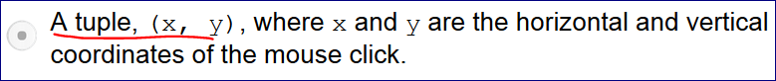

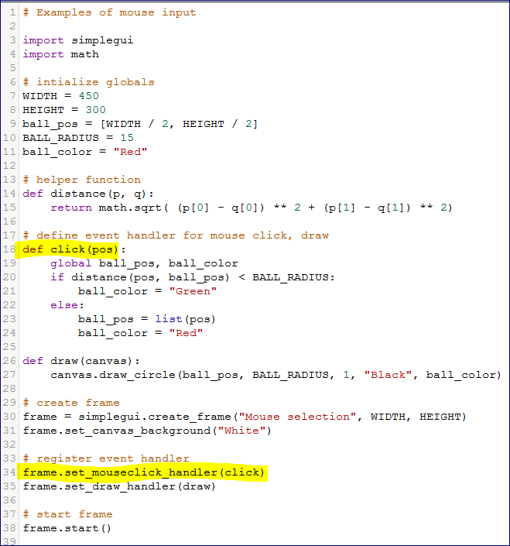

List methods (11:32)

<http://www.codeskulptor.org/#user14_zuGQUlzAba_1.py>

# List methods

lst = [1, 82, -6, 3, 8]

print lst[0]

print lst[-1]

# "in" -- checks if smth is in the list

# "index" -- shows where it is in the list

print lst.index(8)

lst.append(632)

print lst

lst.pop()

print lst

lst.pop(4)

print lst

lst.remove(3)

print lst

Never remove from the list you are iterating. Put the selection into a different list and then remove items from the original list based on the selection.

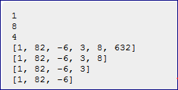

<http://www.codeskulptor.org/#examples-list_methods.py>

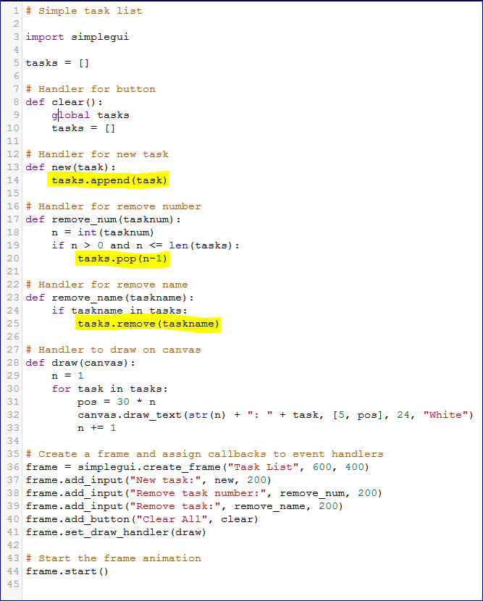

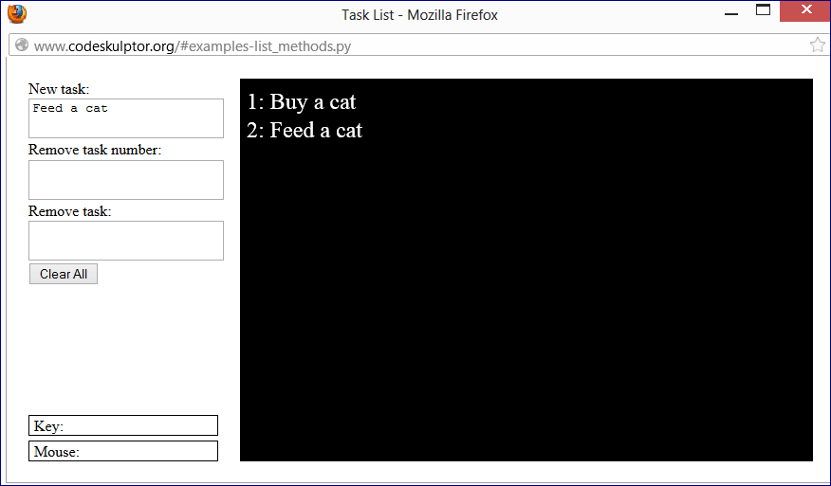

List examples (11:34)

<http://www.codeskulptor.org/#examples-list_of_balls.py>

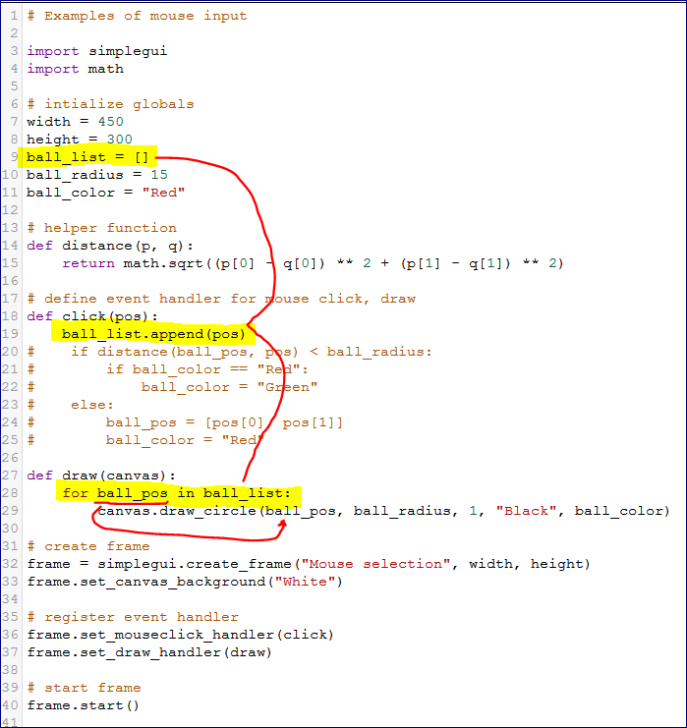

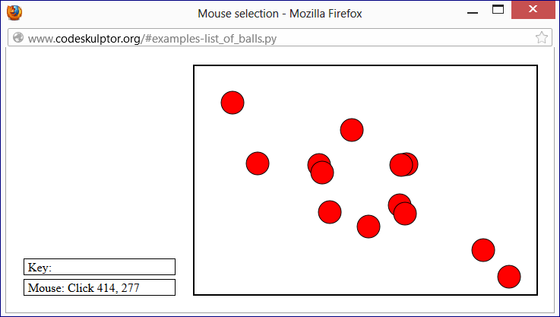

<http://www.codeskulptor.org/#examples-list_selection.py>

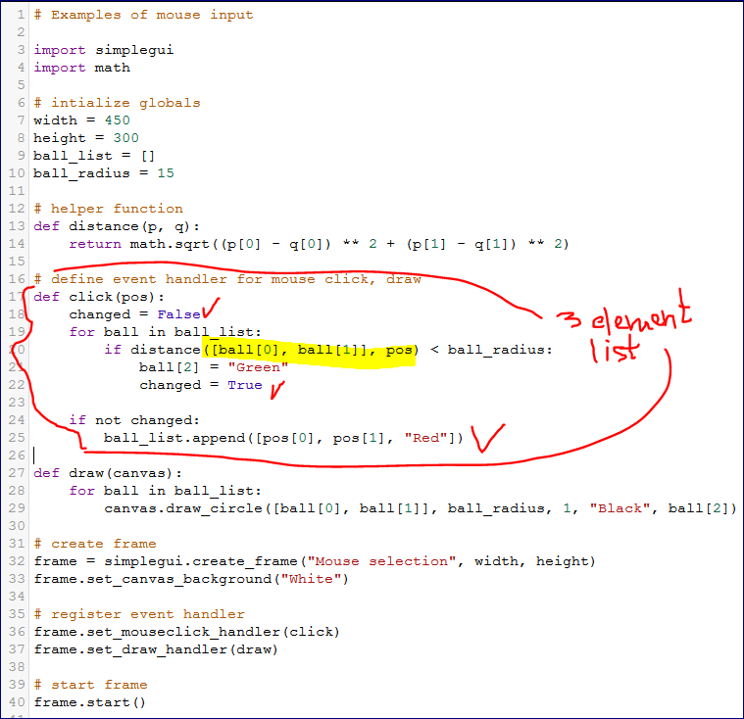

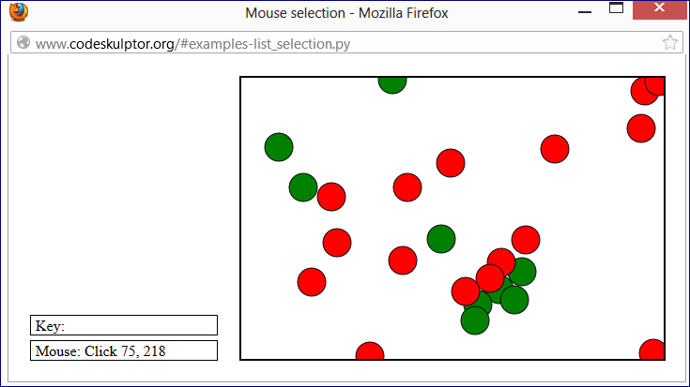

<http://www.codeskulptor.org/#examples-list_removal.py>

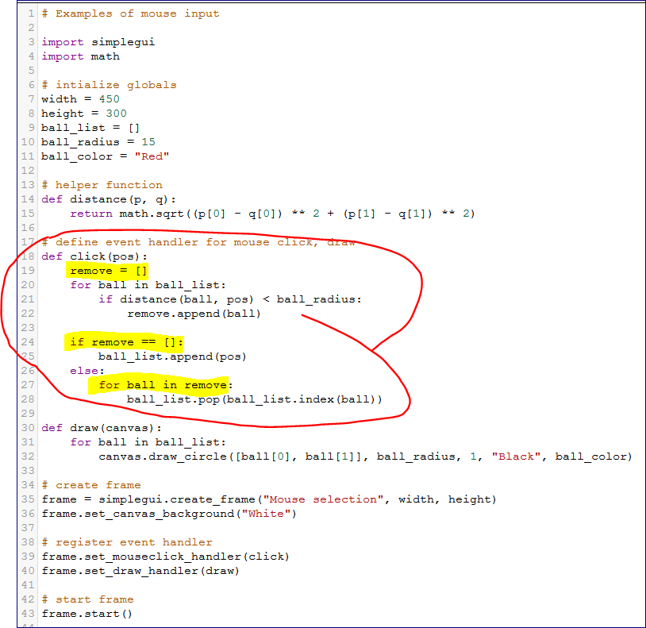

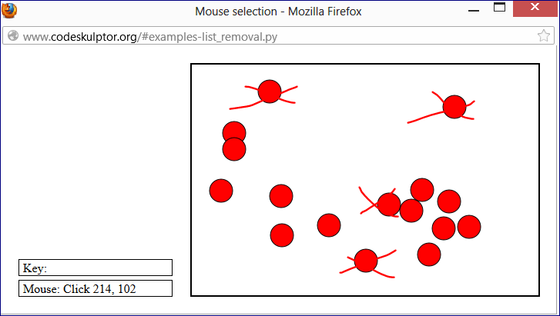

#-----------------------

# Quiz 5a

#-----------------------

fruits = ["apple", "pear", "blueberry"]

fruit = fruits.pop()

print fruit, fruits

print range(2, 15, 3)

print range(14, 1, -3)

print range(2, 14, 3)

print #-------------------------#

# Compute a product of numbers in a list

#--------------------------------

numbers = [1, 3, 6, 7]

product = numbers[0]

print product

for n in numbers:

product *= n

print product

print #-------------------------#

# Reverse a string

#--------------------------------

def reverse_string(s):

"""Returns the reversal of the given string."""

result = ""

for char in s:

result = char + result

return result

print reverse_string("hello")

print #-------------------------#

# Randomly assign each player a starting point

#--------------------------------

import random

def random_point():

"""Returns a random point on a 100x100 grid."""

return (random.randrange(100), random.randrange(100))

def starting_points(players):

"""Returns a list of random points, one for each player."""

points = []

for player in players:

point = random_point()

points.append(point)

#points.extend(point)

return points

print starting_points([1,2,3])

print #-------------------------#

# Question 8

# Check whether the given list of numbers is in ascending order.

#--------------------------------

def is_ascending(numbers):

"""Returns whether the given list of numbers is in ascending order."""

for i in range(len(numbers) - 1):

if numbers[i+1] < numbers[i]:

return False

return True

print is_ascending([2, 6, 9, 12, 400]) # TRUE

print is_ascending([4, 8, 2, 13]) # FALSE

print #-------------------------#

print "Question 9"

#Create a list with two numbers, 0 and 1, respectively.

#For 40 times, add to the end of the list the sum of the last two numbers.

# What is the last number in the list?

#To test your code, if you repeat 10 times, rather than 40,

#your answer should be 89.

lst = [0,1]

for i in range (1,41):

print i

lst.append(lst[-1] + lst[-2])

print lst

#for item in lst:

# lst.append(lst[-1] + lst[-2])

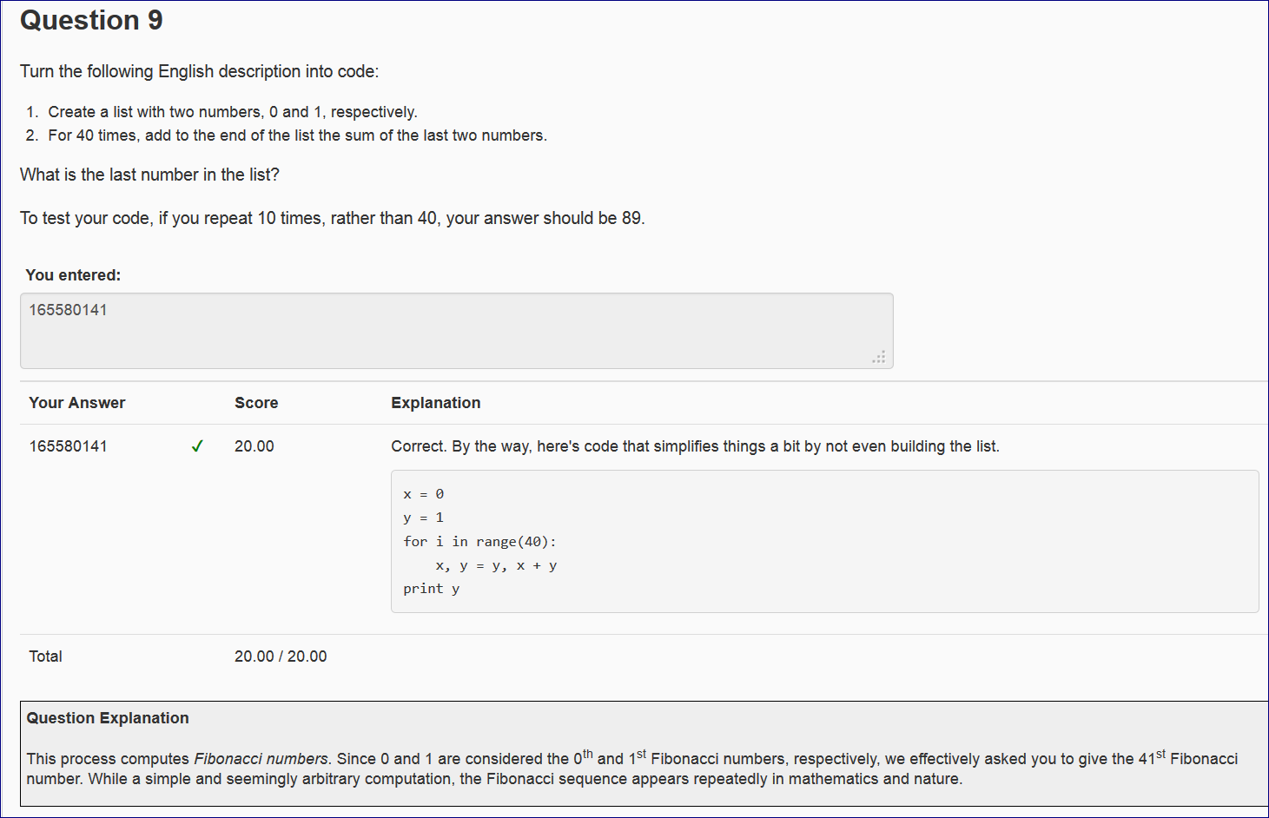

<http://www.codeskulptor.org/#user14_Am7J3pcGEB_5.py>

Dictionaries (12:18)

**Dictionary in Python is actually "MAPPING"**

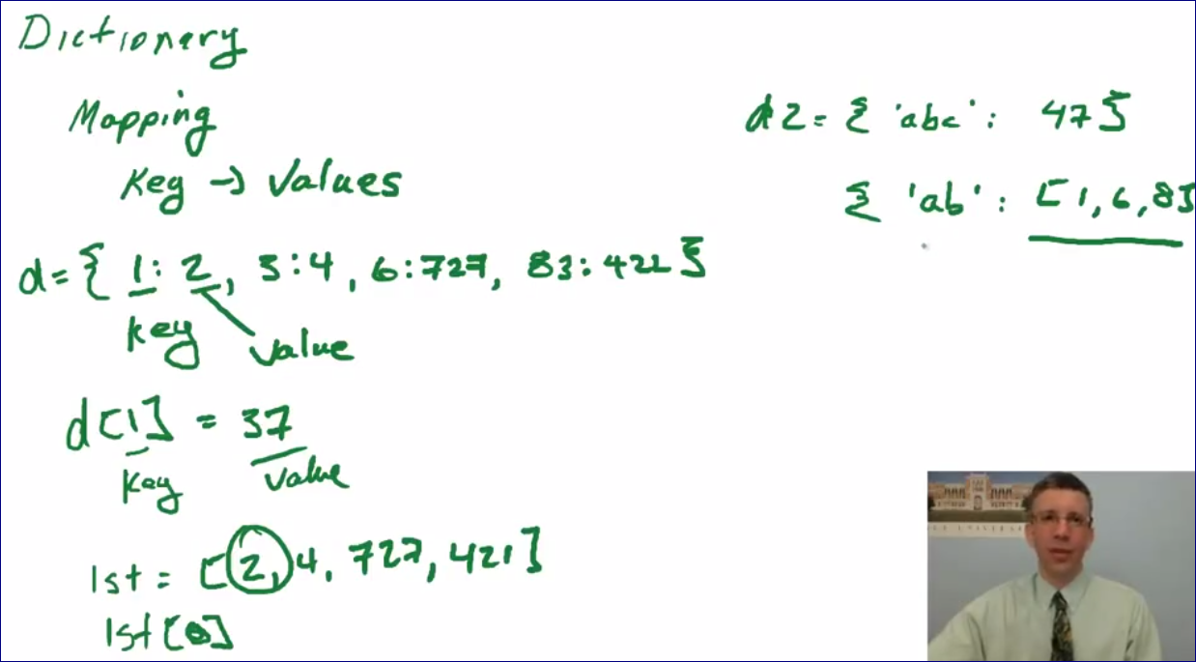

KEY -- "words"

Values -- "definitions"

<http://www.codeskulptor.org/#examples-dictionaries.py>

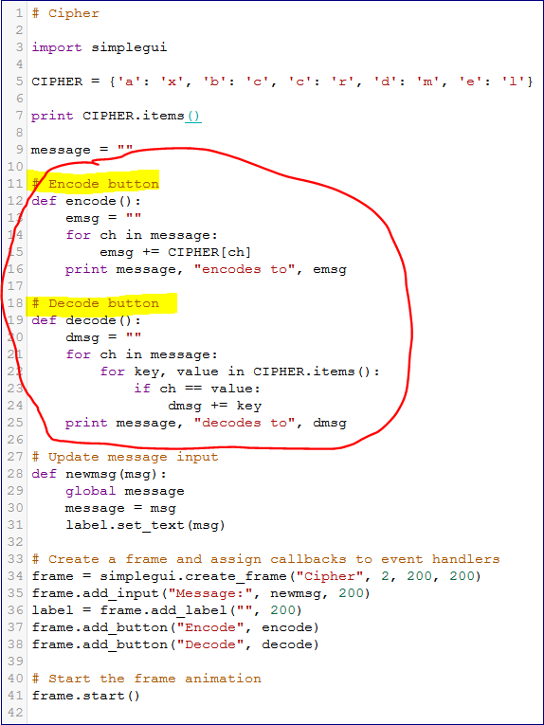

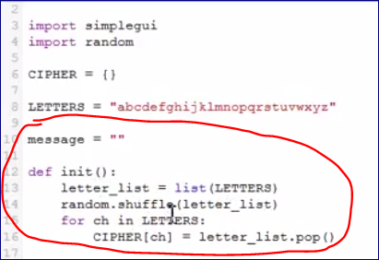

Images (11:00)

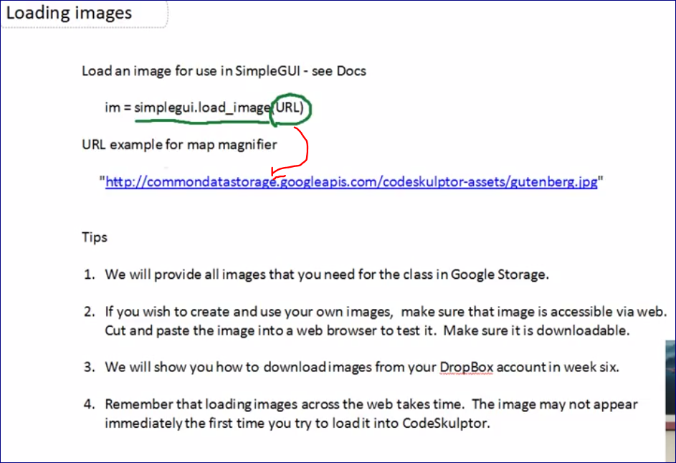

<http://commondatastorage.googleapis.com/codeskulptor-assets/gutenberg.jpg>

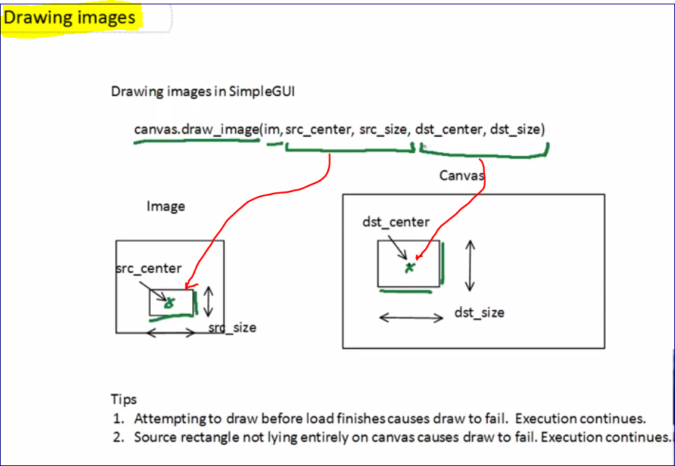

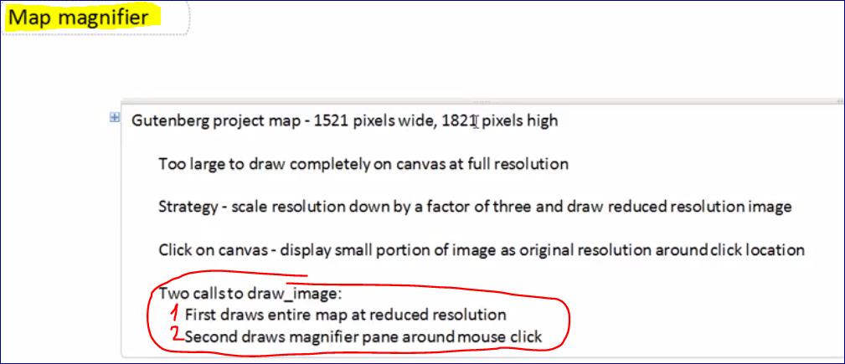

<http://www.codeskulptor.org/#examples-images.py>

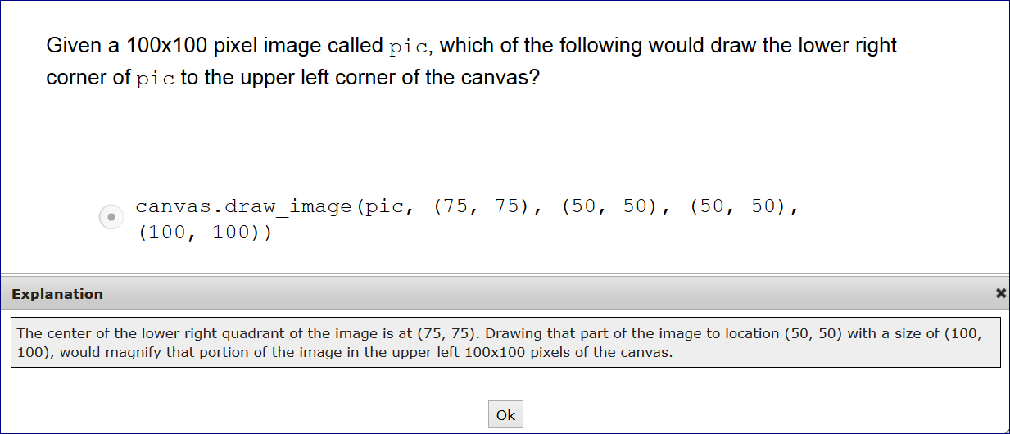

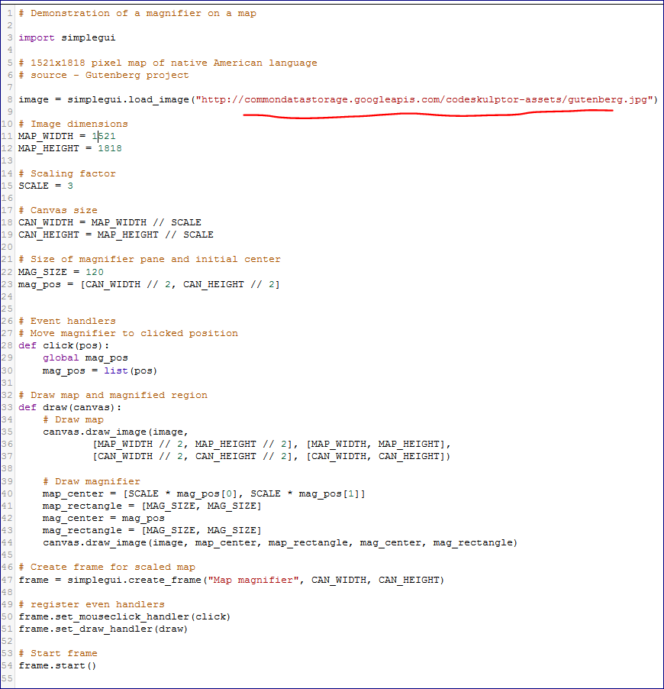

Programming tips - 5 (15:51)

<http://www.codeskulptor.org/#examples-tips5.py>

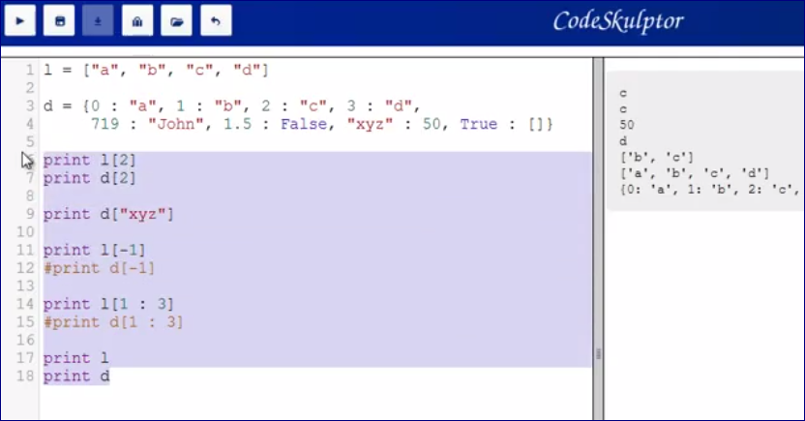

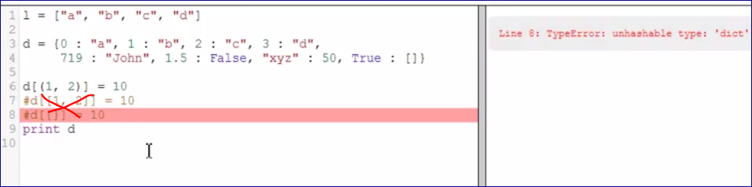

**Mutable types cannot be the KEYS of the dictionary.**

**They can work as values though.**

<http://www.codeskulptor.org/#user14_rFhv8jBo2q_0.py>

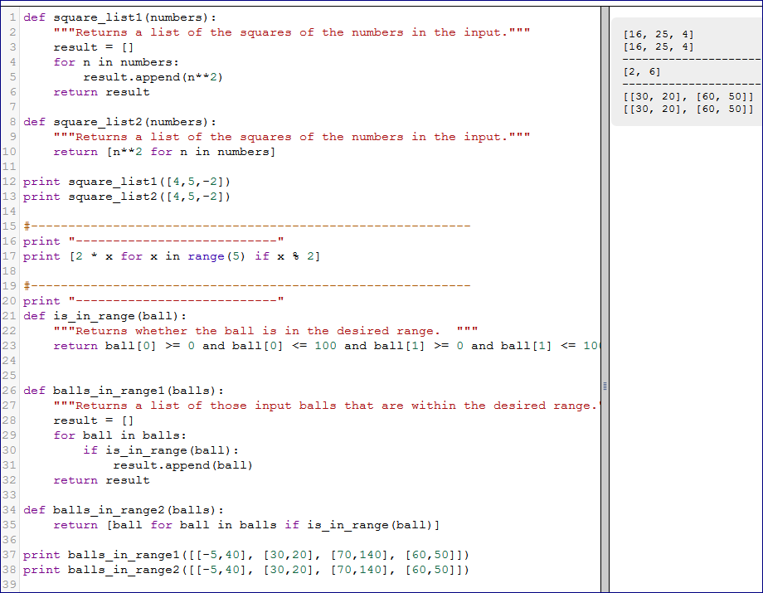

my_list = [3,4,77]

def is_even(number):

"""Returns whether the number is even."""

return number % 2 == 0

print [is_even(number) for number in my_list]

**Quiz 5b**

<http://www.codeskulptor.org/#user14_tYXvQ5QkMV_1.py>

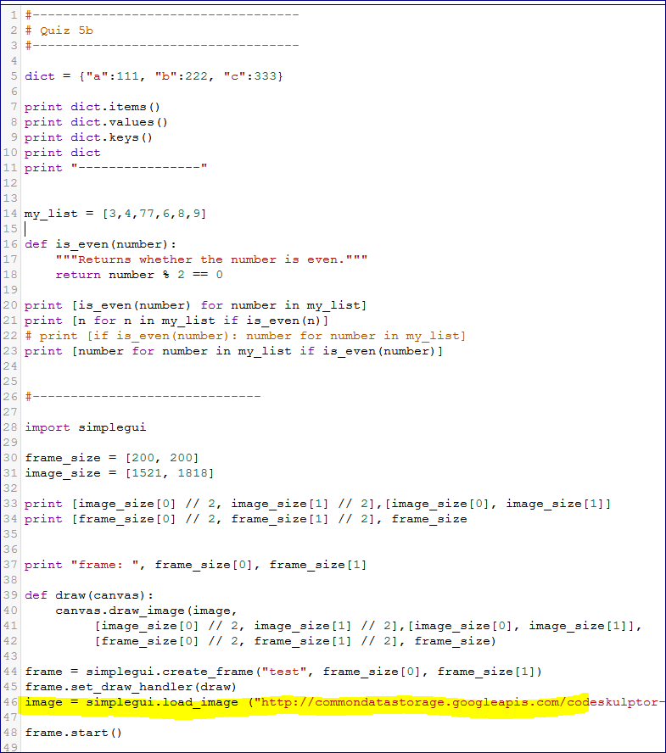

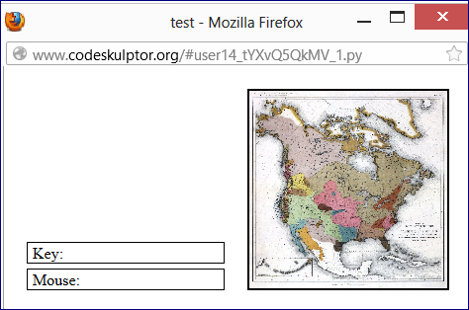

<http://www.codeskulptor.org/#user14_XofK4OdYRE_1.py>

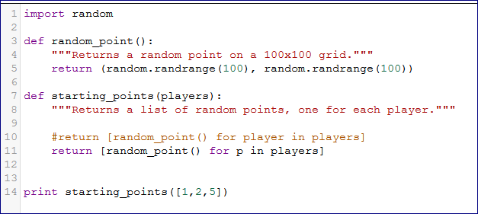

## Week six

**Object-oriented programming** — Object-oriented programming

* All data entities in Python are objects. Compound objects consist of multiple pieces of data.
* New types of compound objects can be defined using the keyword class.
* The data for objects in the class are contained in user-defined fields.
* Functions that manipulate the data in these fields are methods.
* Lecture examples - [Character](http://www.codeskulptor.org/#examples-oo-character.py), [Ball](http://www.codeskulptor.org/#examples-oo-ball.py)
* More examples - [Class Structure](http://www.codeskulptor.org/#examples-more-6_object_oriented_programming-class_structure.py), [Class Errors](http://www.codeskulptor.org/#examples-more-6_object_oriented_programming-class_errors.py)

**Class fields and methods** — Object-oriented programming

* The class initializer __init__ generates instances of class objects.
* The first parameter to class methods is, by convention, always named self.
* Class fields for an object are defined/modified via self.class_field = ...
* Objects created via __init__ for user-defined class are mutable. Subsequent modification of a class fields mutates the object.
* Lecture examples - [Character](http://www.codeskulptor.org/#examples-oo-character.py), [Blackjack Template](http://www.codeskulptor.org/#examples-blackjack_template.py)
* More examples - [Class Structure](http://www.codeskulptor.org/#examples-more-6_object_oriented_programming-class_structure.py), [Class Errors](http://www.codeskulptor.org/#examples-more-6_object_oriented_programming-class_errors.py), [Bubbles](http://www.codeskulptor.org/#examples-more-6_object_oriented_programming-bubbles.py), [Flowers](http://www.codeskulptor.org/#examples-more-6_object_oriented_programming-flowers.py)

**Tiled images** — Tiled images

* A tiled image is a single image that consists of a set of smaller images laid out in a regular grid.
* Tield images are useful since loading a single large image is faster than loading many small images.
* Small images in the tiled image can be drawn by specifying the appropriate source rectangle for draw_image using the size of the small image and its position in the grid.
* Lecture examples - [Tiled Images](http://www.codeskulptor.org/#examples-tiled_images.py)
* More examples - [Bunny Emotions](http://www.codeskulptor.org/#examples-more-6_tiled_images-bunny_emotions.py)

**Programming Tips** — [Week 6](http://www.codeskulptor.org/#examples-tips6.py), [Prime Numbers (while loops)](http://www.codeskulptor.org/#examples-more-6_while_loops-prime_numbers.py)

**Object-oriented programming - 1 (9:34)**

<http://www.codeskulptor.org/#examples-oo-character.py>

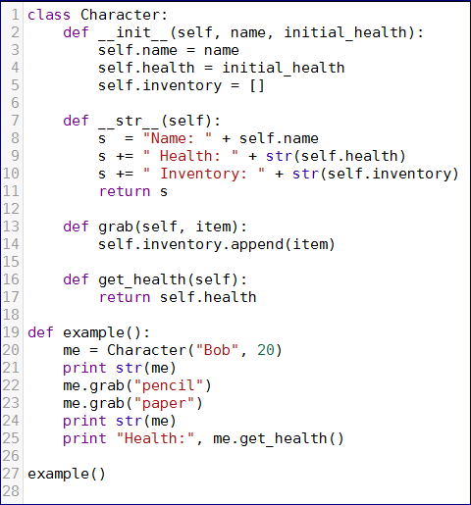

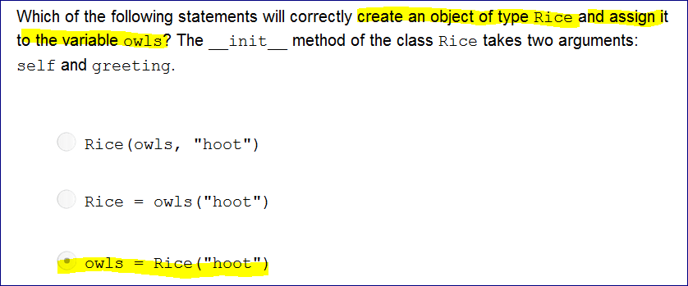

**Object-oriented programming - 2 (8:43)**

<http://www.codeskulptor.org/#examples-oo-ball.py>

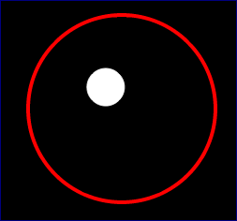

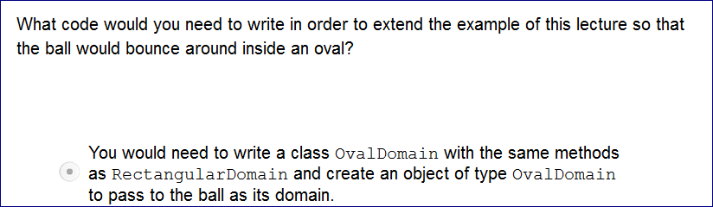

**Working with objects (13:24)**

<http://www.codeskulptor.org/#examples-particle_class.py>

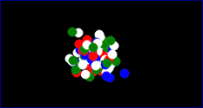

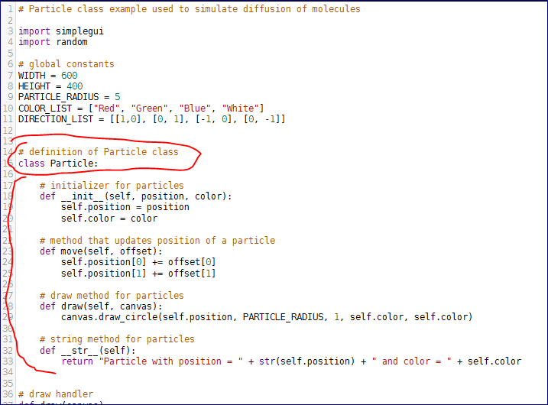

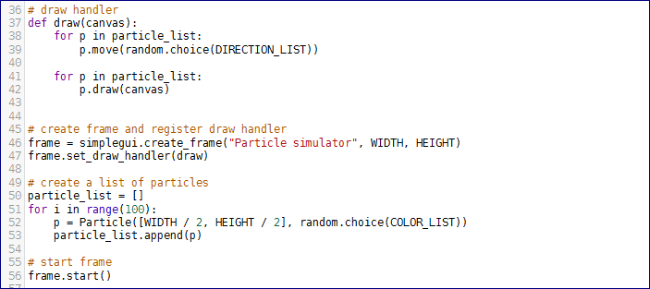

<http://www.codeskulptor.org/#examples-particle_testing_template.py>



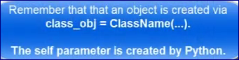

**Quiz 6a**

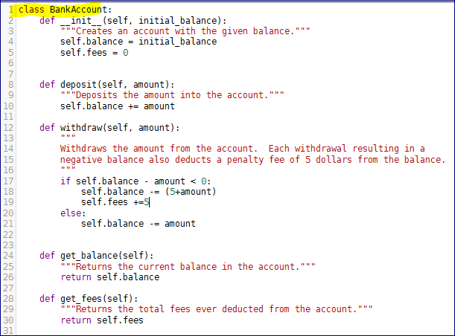

class BankAccount:

def __init__(self, initial_balance):

"""Creates an account with the given balance."""

self.balance = initial_balance

self.fees = 0

def deposit(self, amount):

"""Deposits the amount into the account."""

self.balance += amount

def withdraw(self, amount):

"""

Withdraws the amount from the account. Each withdrawal resulting in a

negative balance also deducts a penalty fee of 5 dollars from the balance.

"""

if self.balance - amount < 0:

self.balance -= (5+amount)

self.fees +=5

else:

self.balance -= amount

def get_balance(self):

"""Returns the current balance in the account."""

return self.balance

def get_fees(self):

"""Returns the total fees ever deducted from the account."""

return self.fees

Classes for Blackjack (11:28)

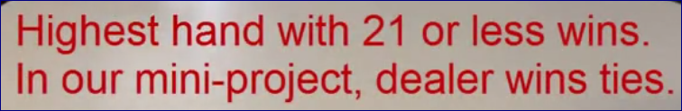

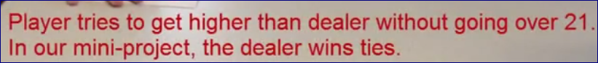

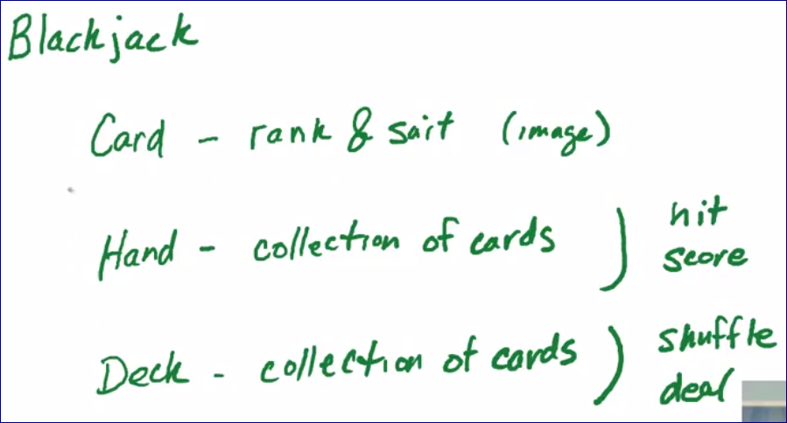

<http://www.codeskulptor.org/#examples-blackjack.py>

# Mini-project #6 - Blackjack

import simplegui

import random

# load card sprite - 950x392 - source: jfitz.com

CARD_SIZE = (73, 98)

card_images = simplegui.load_image("http://commondatastorage.googleapis.com/codeskulptor-assets/cards.jfitz.png")

CARD_BACK_SIZE = (71, 96)

card_back = simplegui.load_image("http://commondatastorage.googleapis.com/codeskulptor-assets/card_back.png")

# initialize global variables

deck = []

in_play = False

outcome = ""

score = 0

# define globals for cards

SUITS = ['C', 'S', 'H', 'D']

RANKS = ['A', '2', '3', '4', '5', '6', '7', '8', '9', 'T', 'J', 'Q', 'K']

VALUES = {'A':1, '2':2, '3':3, '4':4, '5':5, '6':6, '7':7, '8':8, '9':9, 'T':10, 'J':10, 'Q':10, 'K':10}

# define card class

class Card:

def __init__(self, suit, rank):

if (suit in SUITS) and (rank in RANKS):

self.suit = suit

self.rank = rank

else:

print "Invalid card: ", self.suit, self.rank

def __str__(self):

return self.suit + self.rank

def get_suit(self):

return self.suit

def get_rank(self):

return self.rank

def draw(self, canvas, pos):

card_loc = (card_size[0] * (0.5 + RANKS.index(self.rank)), card_size[1] * (0.5 + SUITS.index(self.suit)))

canvas.draw_image(card_images, card_loc, card_size, [pos[0] + card_size[0] / 2, pos[1] + card_size[1] / 2], card_size)

# define hand class

class Hand:

def __init__(self):

pass # replace with your code

def __str__(self):

pass # replace with your code

def add_card(self, card):

pass # replace with your code

# count aces as 1, if the hand has an ace, then add 10 to hand value if don't bust

def get_value(self):

pass # replace with your code

def busted(self):

pass # replace with your code

def draw(self, canvas, p):

pass # replace with your code

# define deck class

class Deck:

def __init__(self):

pass # replace with your code

# add cards back to deck and shuffle

def shuffle(self):

pass # replace with your code

def deal_card(self):

pass # replace with your code

#define callbacks for buttons

def deal():

global outcome, in_play

# your code goes here

outcome = ""

in_play = True

def hit():

pass # replace with your code below

# if the hand is in play, hit the player

# if busted, assign an message to outcome, update in_play and score

def stand():

pass # replace with your code below

# if hand is in play, repeatedly hit dealer until his hand has value 17 or more

# assign a message to outcome, update in_play and score

def draw(canvas):

pass # replace with your code below

# initialization frame

frame = simplegui.create_frame("Blackjack", 600, 600)

frame.set_canvas_background("Green")

#create buttons and canvas callback

frame.add_button("Deal", deal, 200)

frame.add_button("Hit", hit, 200)

frame.add_button("Stand", stand, 200)

frame.set_draw_handler(draw)

# deal an initial hand

# get things rolling

frame.start()

# Grading rubric - 18 pts total (scaled to 100)

# 1 pt - The program opens a frame with the title "Blackjack" appearing on the canvas.

# 3 pts - The program displays 3 buttons ("Deal", "Hit" and "Stand") in the control area. (1 pt per button)

# 2 pts - The program graphically displays the player's hand using card sprites.

# (1 pt if text is displayed in the console instead)

# 2 pts - The program graphically displays the dealer's hand using card sprites.

# Displaying both of the dealer's cards face up is allowable when evaluating this bullet.

# (1 pt if text displayed in the console instead)

# 1 pt - Hitting the "Deal" button deals out new hands to the player and dealer.

# 1 pt - Hitting the "Hit" button deals another card to the player.

# 1 pt - Hitting the "Stand" button deals cards to the dealer as necessary.

# 1 pt - The program correctly recognizes the player busting.

# 1 pt - The program correctly recognizes the dealer busting.

# 1 pt - The program correctly computes hand values and declares a winner.

# Evalute based on player/dealer winner messages.

# 1 pt - The dealer's hole card is hidden until the hand is over when it is then displayed.

# 2 pts - The program accurately prompts the player for an action with the messages

# "Hit or stand?" and "New deal?". (1 pt per message)

# 1 pt - The program keeps score correctly.

Tiled images (15:06)

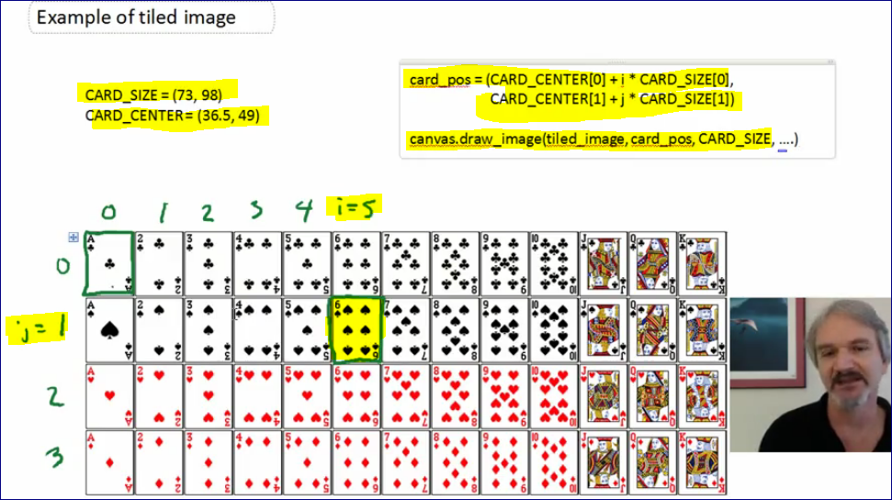

<http://www.codeskulptor.org/#examples-tiled_images.py>

* **Clubs**
* **Spades**
* **Hearts**
* **Diamonds**

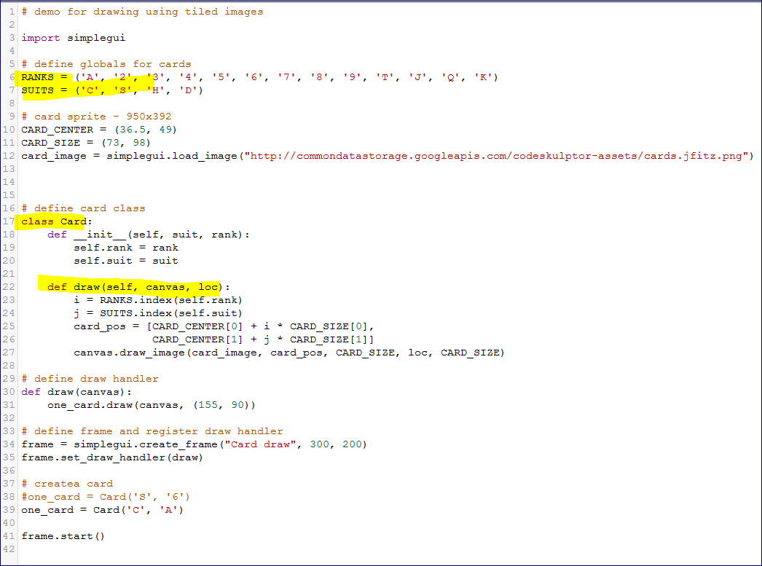

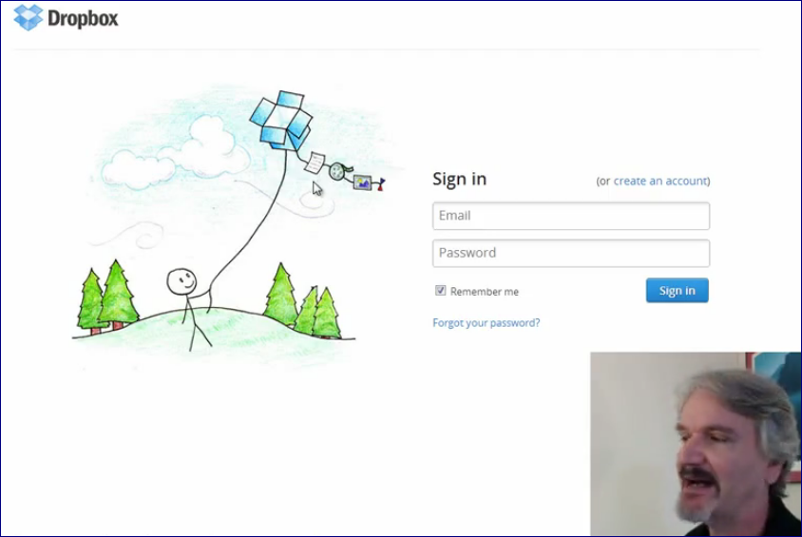

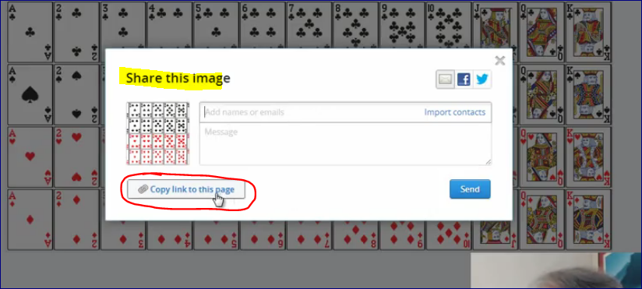

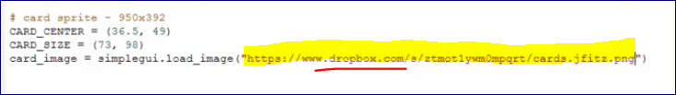

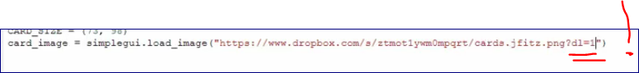

There are some changes. Read the comment thread.

**Always check your program on a new computer as images are cashed on yours and that may not be the same on another machine.**

Programming tips - 6 (16:30)

Self – is an object itself.

<http://www.codeskulptor.org/#user15_9QpN2CMFHr_0.py>

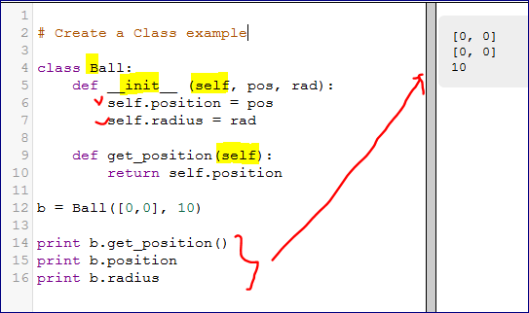

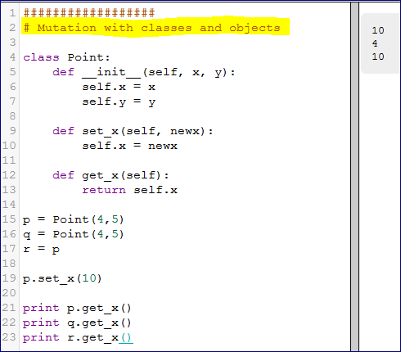

Blackjack (14:38)

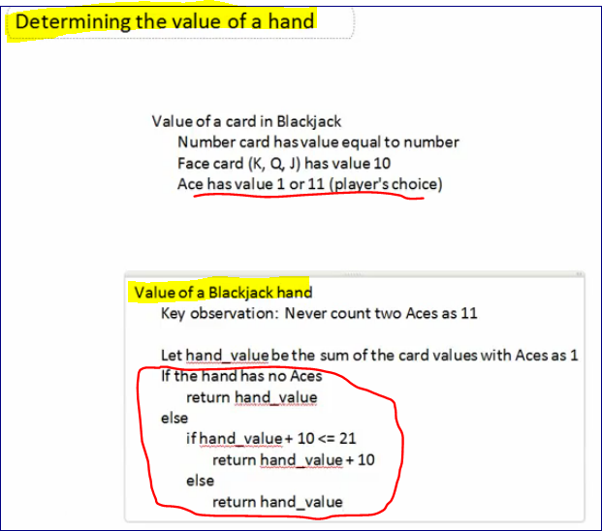

**Dealer**

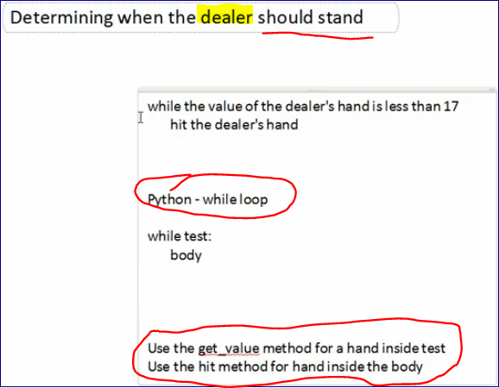

**Python Template**

<http://www.codeskulptor.org/#examples-blackjack_template.py>

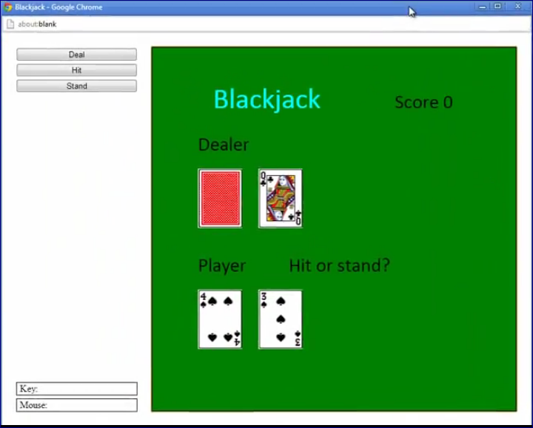

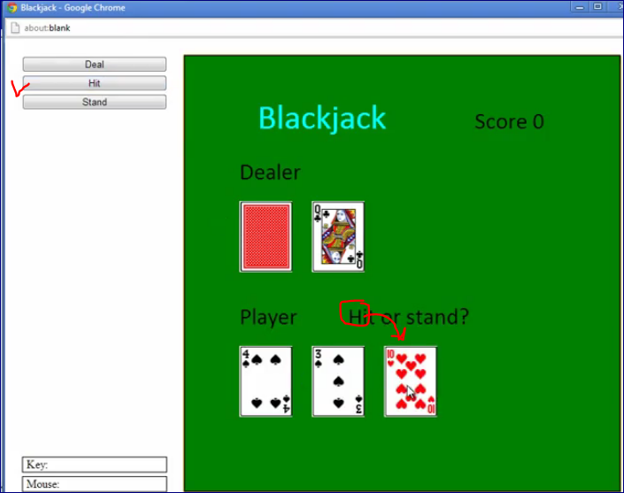

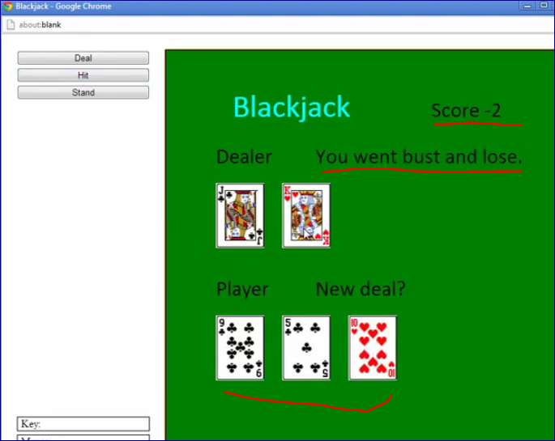

<https://class.coursera.org/interactivepython-002/forum/thread?thread_id=6263&post_id=31085#post-31085>

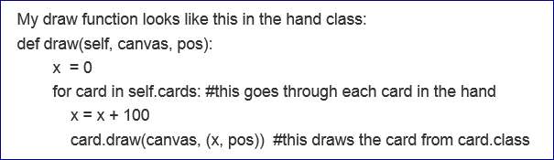

-------------------------------------===================================

## Week seven

[Learn more.](http://support.coursera.org/customer/portal/articles/823871-adding-course-pages)[Discuss](https://class.coursera.org/mooc/forum/tag?name=CoursePage&forum_id=7)

**Acceleration control — Acceleration and friction**

* Basic physics relates the position of a point p, its velocity vector v and its acceleration vector a via the update equations   
  p += v   
  v += a
* In the absence of friction, the acceleration vector for the Asteroids ship is a scaled version of the forward vector f where f = [cos(θ), sin(θ)]. Here, θ is the angle with the horizontal axis.
* Application of acceleration using the forward thrust vector is controlled using keyboard input.
* To add friction to this model, the velocity of the ship is continually decelerated via the update v = e * v where e is a constant slightly smaller than 1.
* Lecture examples - None
* More examples - [Curling (friction)](http://www.codeskulptor.org/#examples-more-7_acceleration_and_friction-curling.py), [Balancing Stick (acceleration)](http://www.codeskulptor.org/#examples-more-7_acceleration_and_friction-balancing.py), [Angle Vectors](http://www.codeskulptor.org/#examples-more-7_vectors-angle_vectors.py)

**Sprites — Sprite class**

* Most object-oriented game environments provide a class structure for 2D graphical/image objects called sprites.
* The Sprite class typically includes fields for quantities such as position, velocity, size and age.
* This class typically includes an initializer, an update method, a draw method and a collision method.
* For the Spaceship and Asteroids mini-projects, sprites have an associated ImageInfo class with fields that contain the center, size, radius, lifespan and animated flag for an image.
* Lecture examples - [Sprite Example](http://www.codeskulptor.org/#examples-sprite_example.py), [Spaceship](http://www.codeskulptor.org/#examples-spaceship.py), [Project Template](http://www.codeskulptor.org/#examples-spaceship_template.py)
* More examples - [Curling](http://www.codeskulptor.org/#examples-more-7_acceleration_and_friction-curling.py)

**RGB colors and HTML color strings**

* In the RGB color model, colors are represented as a triple of integers in the range of 0 to 255.
* Each component corresponds to red, green and blue, respectively. The value of the component corresponds to the intensity of the corresponding color, with 0 being no intensity and 255 being full intensity.
* HTML color strings encode RGB colors as a string "rgb(r,g,b)" where the three values lie in the range 0 to 255.
* An extra alpha channel may be added to control transparency. The HTML color string has the form "rgba(r,g,b,a)" where a is in the the range 0 (transparent) to 1 (opaque).
* Lecture examples - None
* More examples - [Fading Dots](http://www.codeskulptor.org/#examples-more-7_colors-fading_dots.py)

**Sound — Sound**

* The SimplGui function load_sound() loads a sound file, specified as a URL, into CodeSkulptor and returns a sound object.
* Th method set_volume() controls the playback volume of the sound.
* The methods play(),pause(),rewind() control the playback of the sound object.
* Attempting to play several versions of the same sound object at the same time in not possible. However, different sounds objects can play on different channels simultaneously.
* Different browser support different sound formats. Short sounds are laggy in Firefox.
* Lecture examples - [Sound](http://www.codeskulptor.org/#examples-sound.py)
* More examples - [Bouncing Ball](http://www.codeskulptor.org/#examples-more-7_sound-bouncing_sounds.py)

**Programming Tips —** [**Week 7**](http://www.codeskulptor.org/#examples-tips7.py)

Acceleration and friction (14:40)

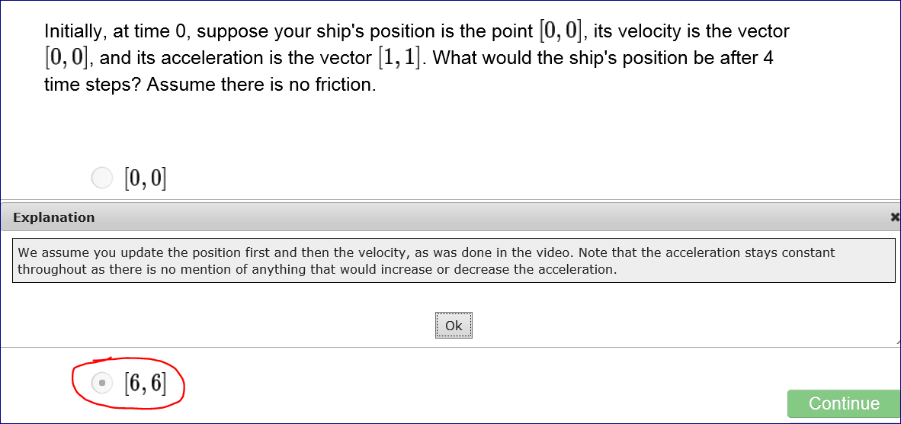

<http://www.codeskulptor.org/#examples-more-7_acceleration_and_friction-curling.py>

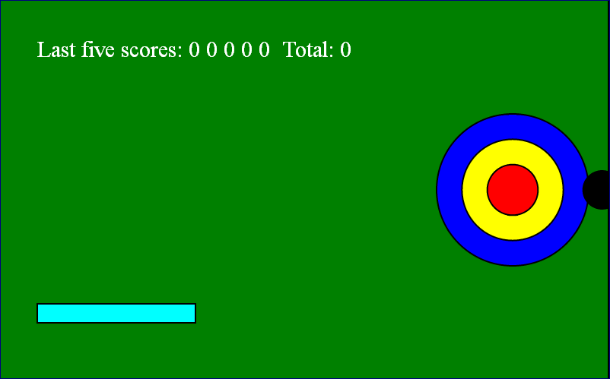

<http://www.codeskulptor.org/#examples-more-7_acceleration_and_friction-balancing.py>

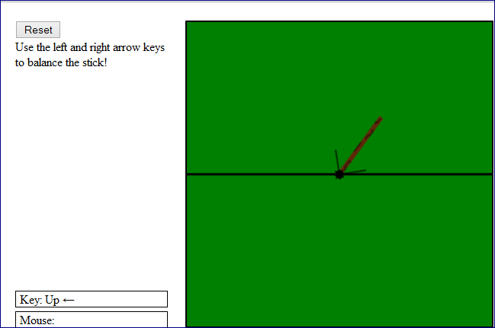

<http://www.codeskulptor.org/#examples-more-7_vectors-angle_vectors.py>

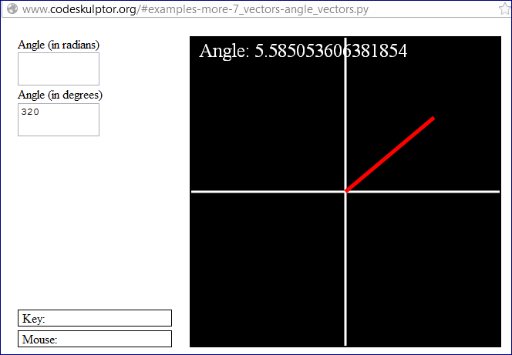

***Examples with sounds***

<http://www.codeskulptor.org/#examples-more-7_sound-bouncing_sounds.py>

Spaceship class (7:54)

<http://www.codeskulptor.org/#examples-spaceship.py>

Sound (5:22)

<http://www.codeskulptor.org/#examples-sound.py>

<http://www.codeskulptor.org/#examples-sound.py>

In SimpleGUI you can load the sound and then you can:

1. Play
2. Pause
3. and Rewind

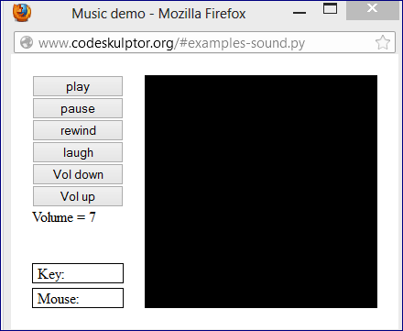

**# load some sounds**

music = simplegui.load_sound("http://commondatastorage.googleapis.com/codeskulptor-assets/Epoq-Lepidoptera.ogg")

laugh = simplegui.load_sound("http://commondatastorage.googleapis.com/codeskulptor-assets/Evillaugh.ogg")

**You can set a volume between 0 and 1**

0 – minimum

1 – maximum

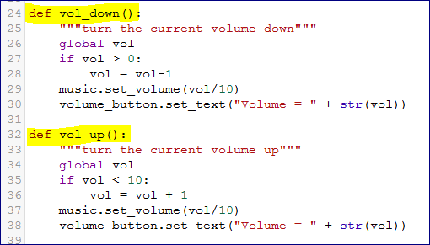

**Working with Classes in Python:**

<http://www.codeskulptor.org/#user16_sQbfbuOTc8_0.py>

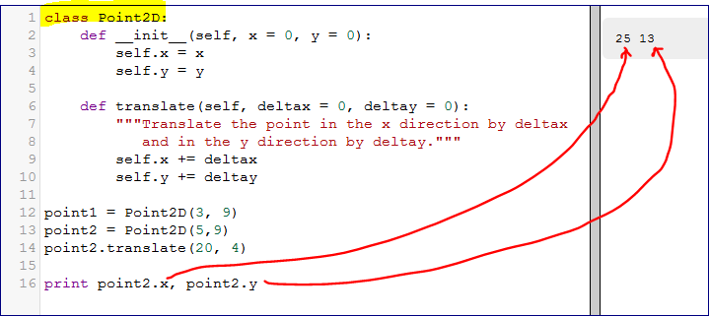

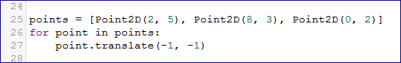

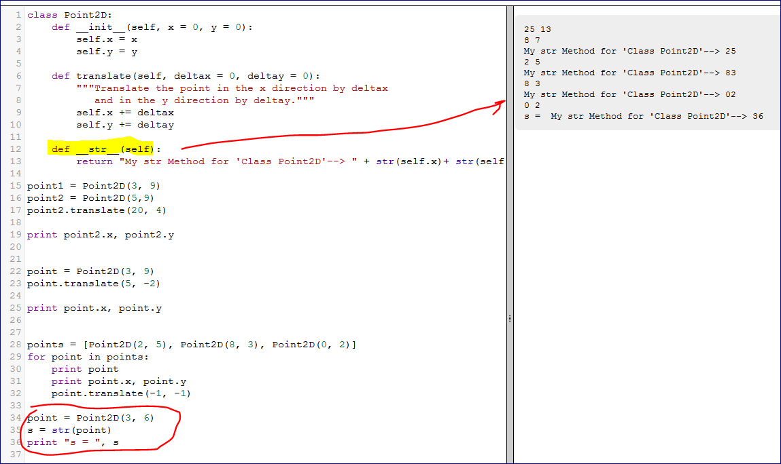

Sprite class (14:21)

Logical units of graphics organized inside the game.

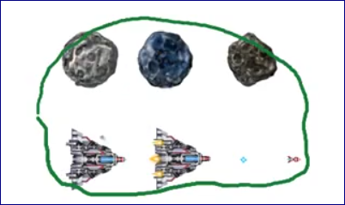

Here we see three sprites corresponding to an asteroid and two sprites corresponding to a ship.

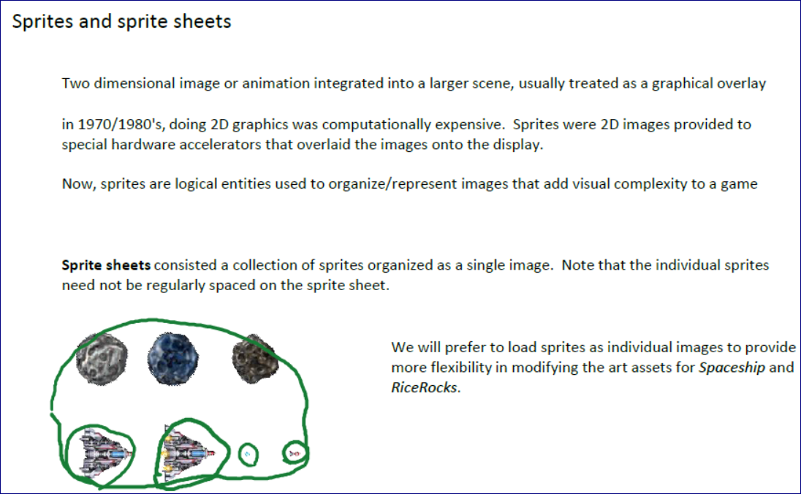

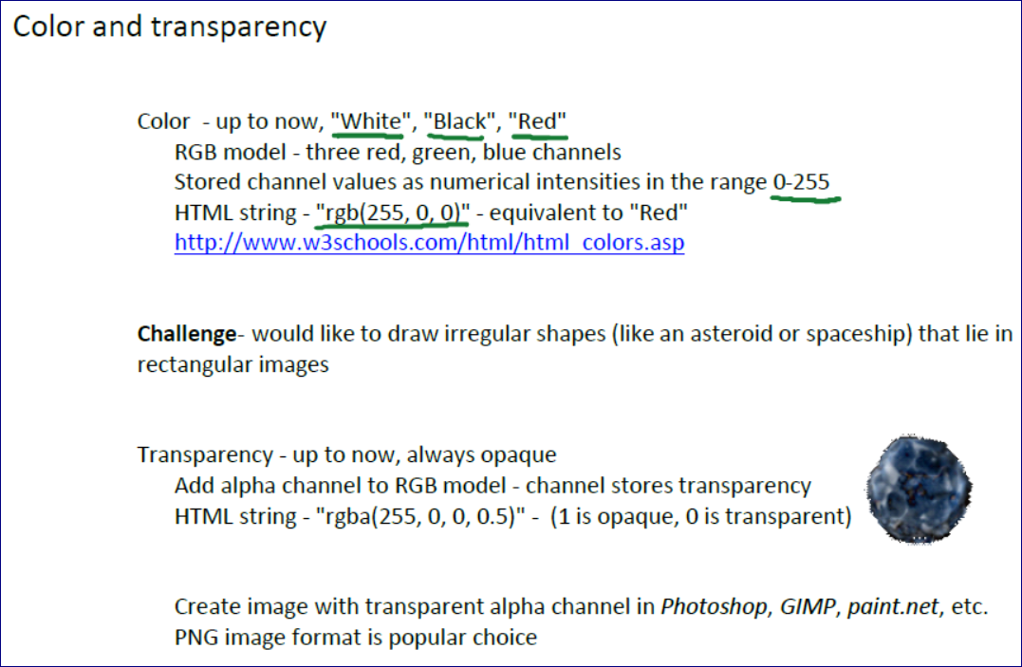

<http://www.w3schools.com/html/html_colors.asp>

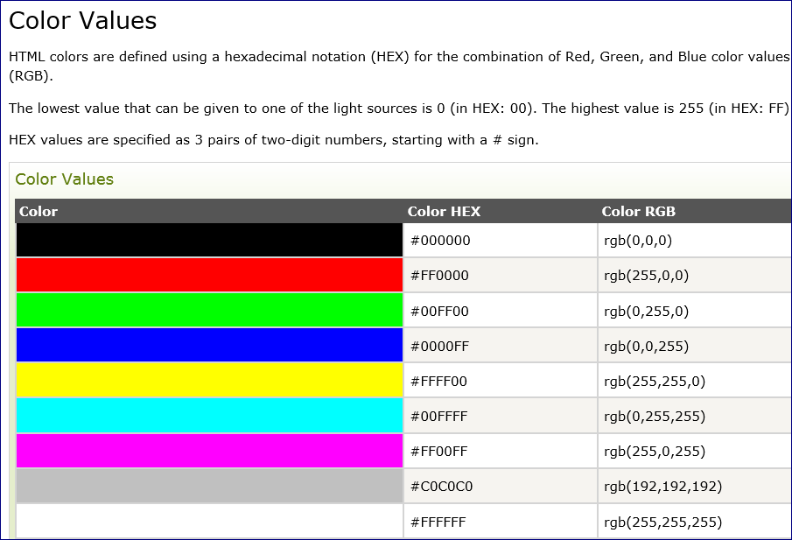

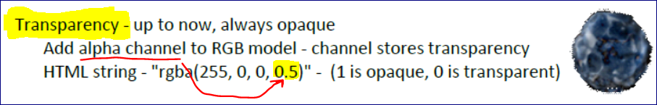

<http://www.codeskulptor.org/#examples-sprite_example.py>

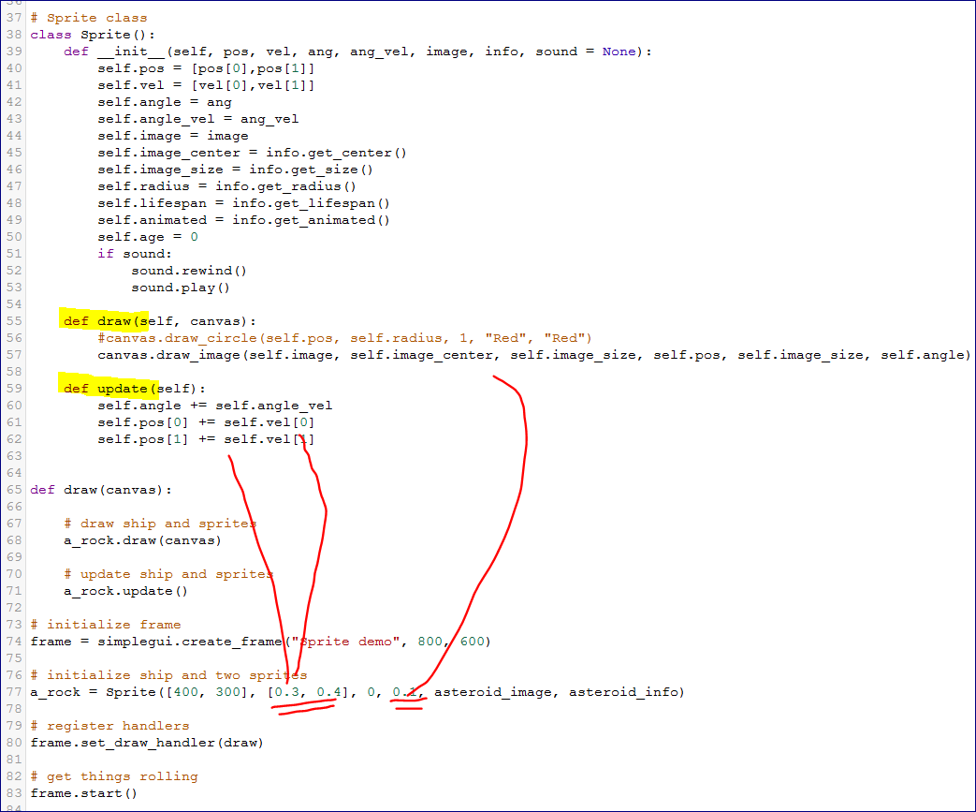

Programming tips - 7 (20:25)

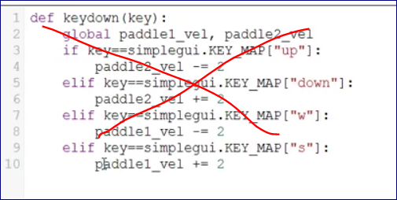

It’s better to map a key to an action

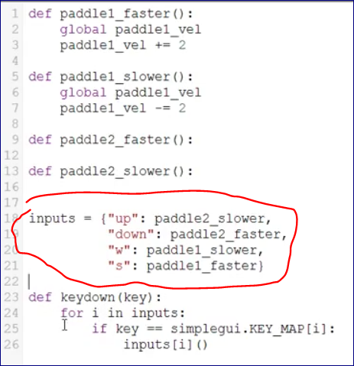

**Look for a function name in the dictionary and call it!!!**

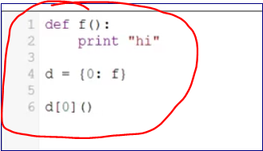

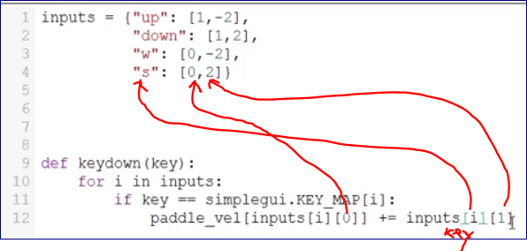

**Working with Classes**

<http://www.codeskulptor.org/#user15_5P7Pbn3bVt_0.py>

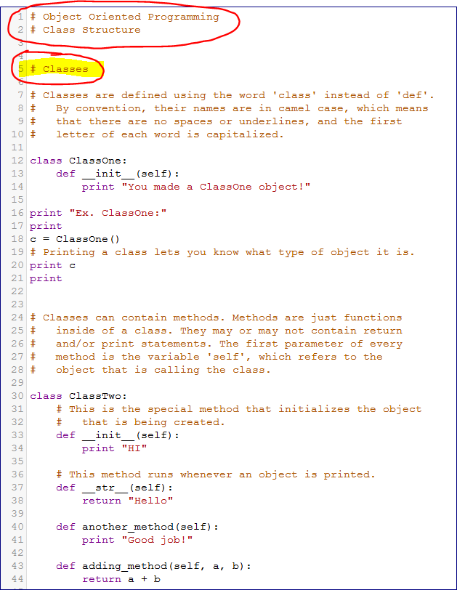

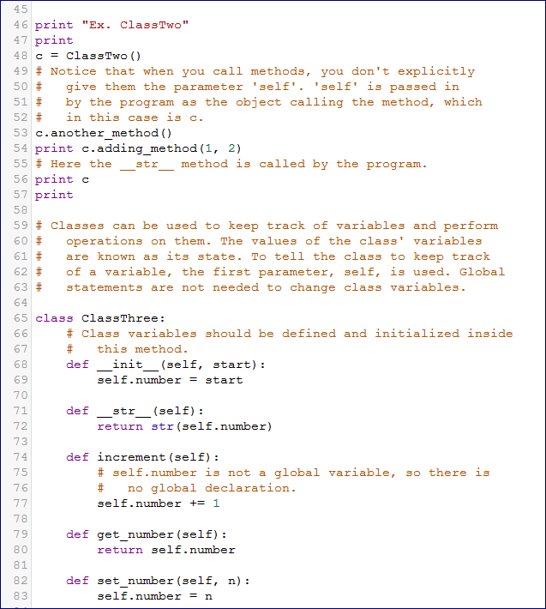

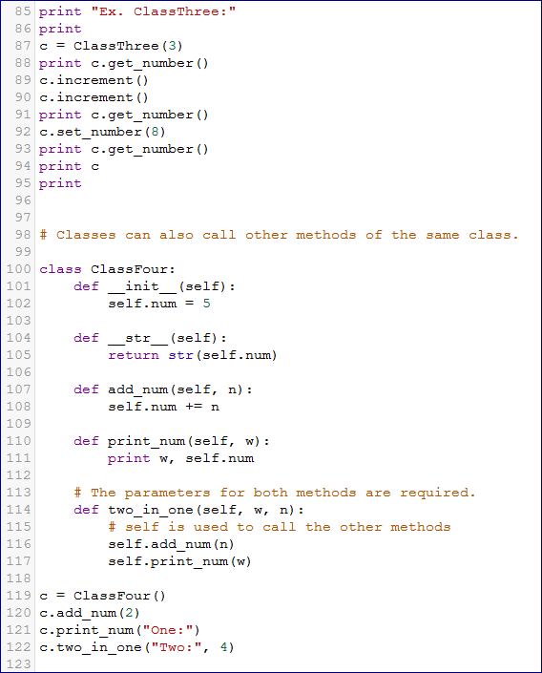

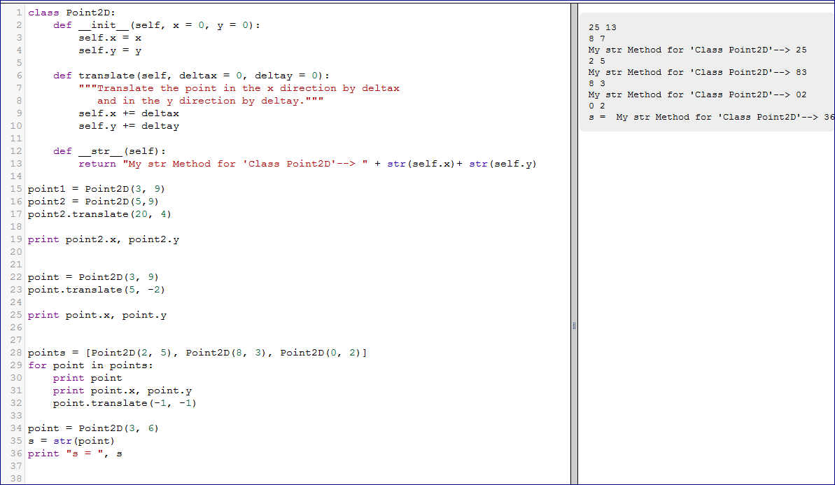

## Week eight

**Sets** — Groups of sprites

* Sets are unordered collections of unique objects. The initializer for Python sets is the function set().
* Items can be added to and removed from a set using the methods add() and remove(), respectively.
* The item membership test for a set uses the keyword in.
* The methods difference() and difference_update() remove a set of items from a set and returns a new set or a mutated versions of the original set, respectively.
* Lecture examples - [Sets](http://www.codeskulptor.org/#examples-sets.py), [Set differences](http://www.codeskulptor.org/#examples-set_difference.py)
* More examples - [Set Structure](http://www.codeskulptor.org/#examples-more-8_sets-structure.py)

**Animation** — Sprite animation

* An animated sprite is drawn by striding the center of the source rectangle in draw_image through the animated sprite's associated tiled image.
* This stride is typically controlled by the sprite's age and size.
* This sprite's lifespan is used to terminate the animation.
* For the Spaceship and Asteroids mini-projects, the stride is always horizontal from left to right.
* Lecture examples - [Asteroid animation](http://www.codeskulptor.org/#examples-asteroid_animation.py), [Explosion animation](http://www.codeskulptor.org/#examples-explosion_animation.py)
* More examples - [Running Bunny](http://www.codeskulptor.org/#examples-more-8_sprite_animation-running_bunny.py)

**Other Examples** — [Balloon Pop (collisions)](http://www.codeskulptor.org/#examples-more-8_collisions-balloon_pop.py), [Project Template](http://www.codeskulptor.org/#examples-ricerocks_template.py)

Sets (11:44)

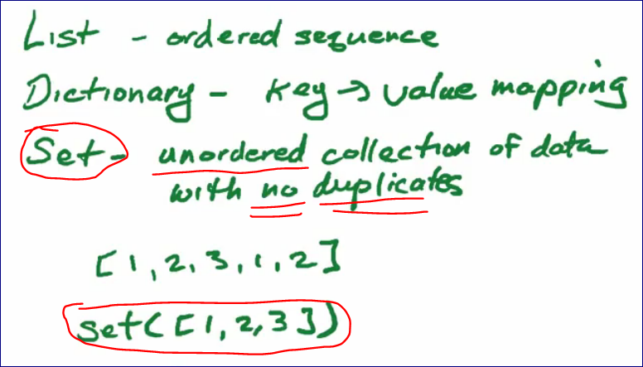

<http://www.codeskulptor.org/#examples-sets.py>

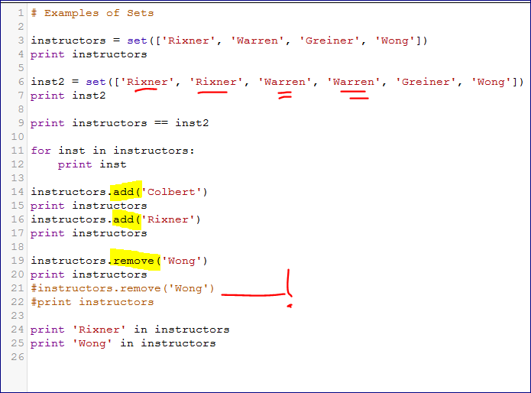

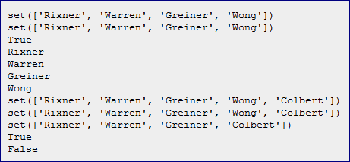

<http://www.codeskulptor.org/#examples-set_difference.py>

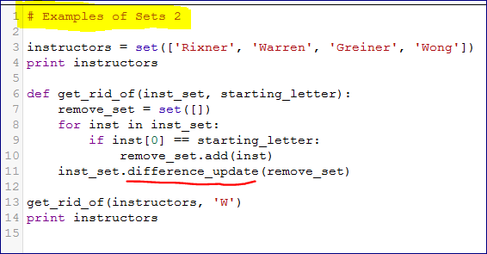

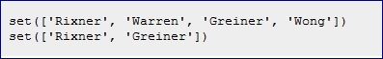

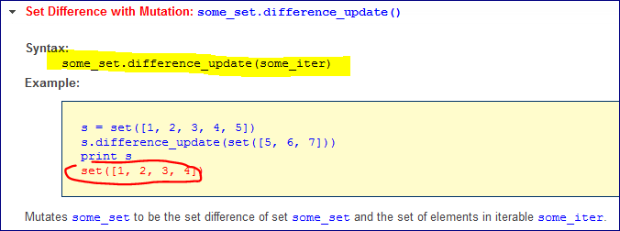

Collisions for sprites (13:38)

Sets allows to keep track of elements.

Sets do not allow to have duplicates.

Sets return (print) the objects they without an ORDER.

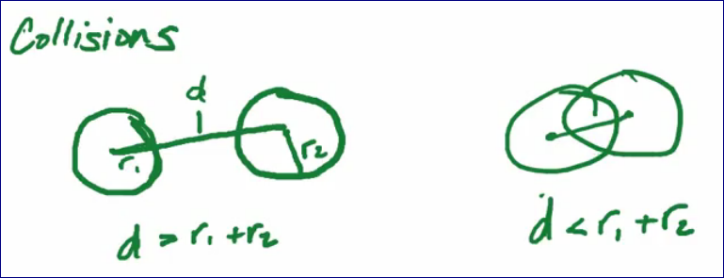

d > r1 + r2 🡪 No collision

d <= r1 + r2 🡪 Collision

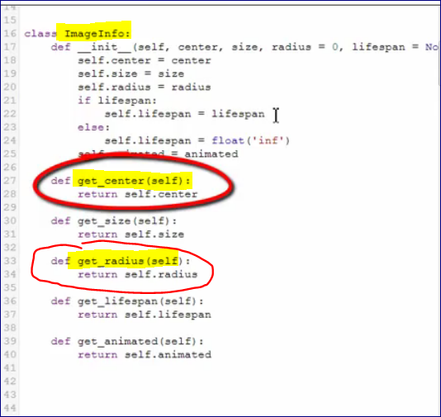

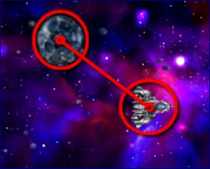

Add “Collision” method to the Sprite class

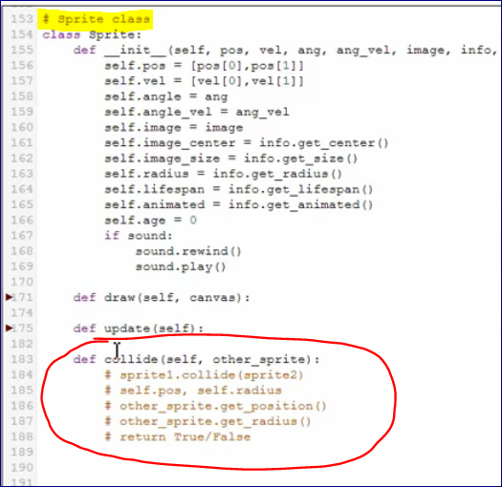

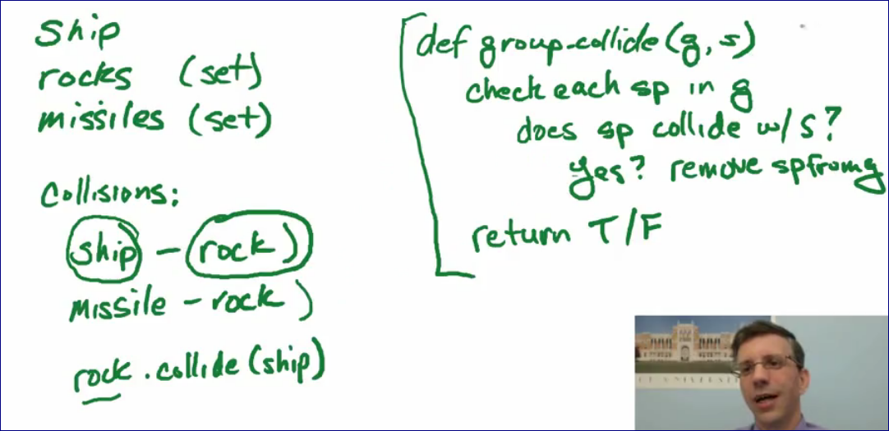

You can iterate through the object (set) and remove items from it.

But copy it to the list first.

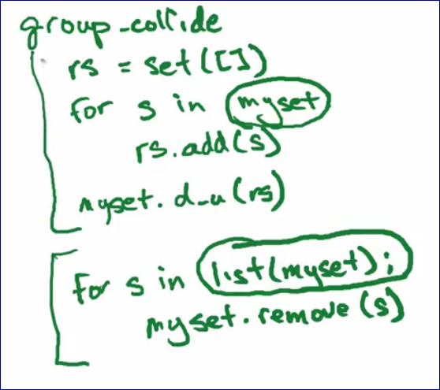

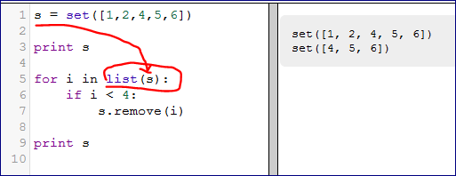

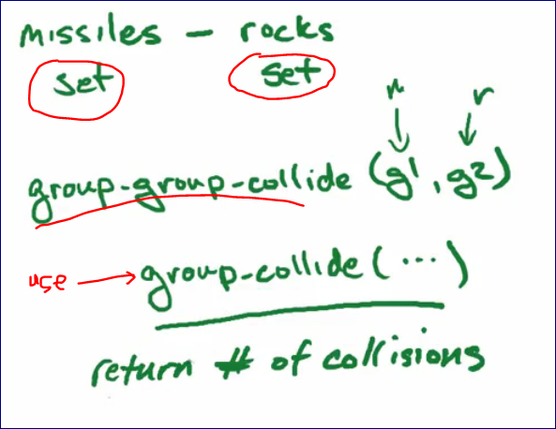

Think about:

* 1. Object – Object collision
  2. Object – Set collision
  3. Set – Set collision

**Sprite animation (12:01)**

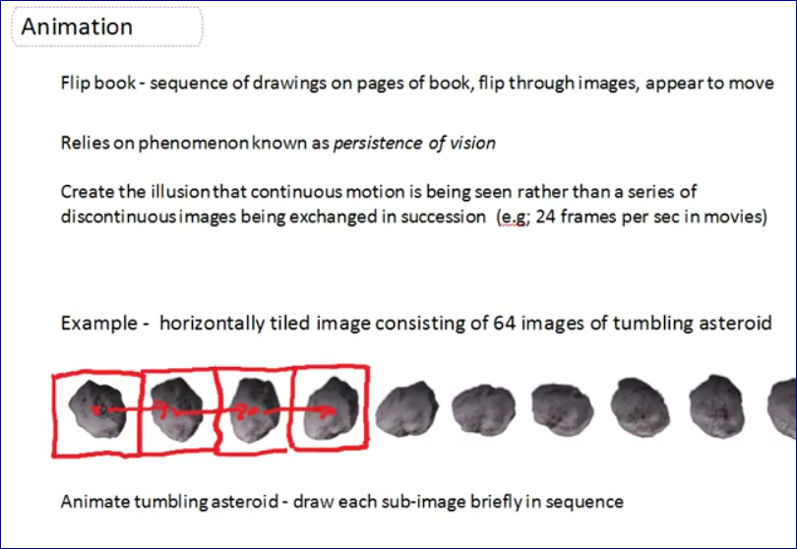

<http://www.codeskulptor.org/#examples-asteroid_animation.py>

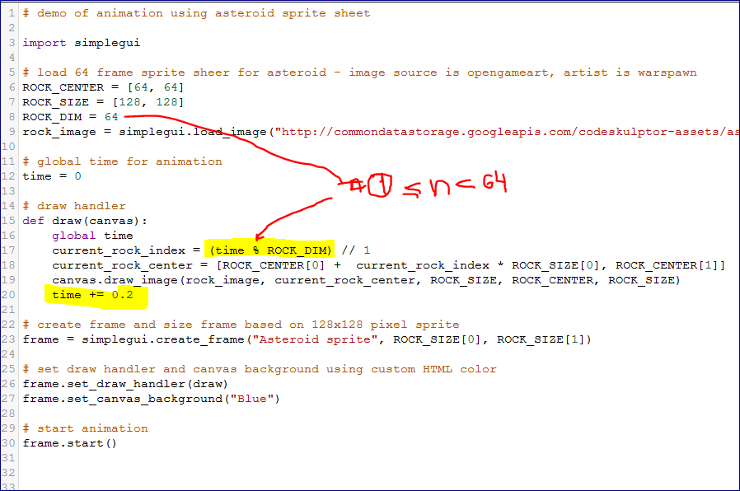

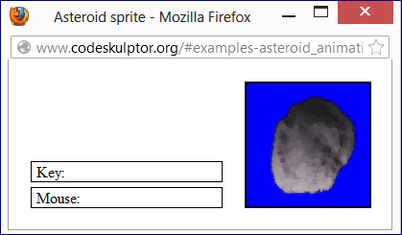

<http://www.codeskulptor.org/#user16_fjfKVeb6fF_0.py>

Explosion

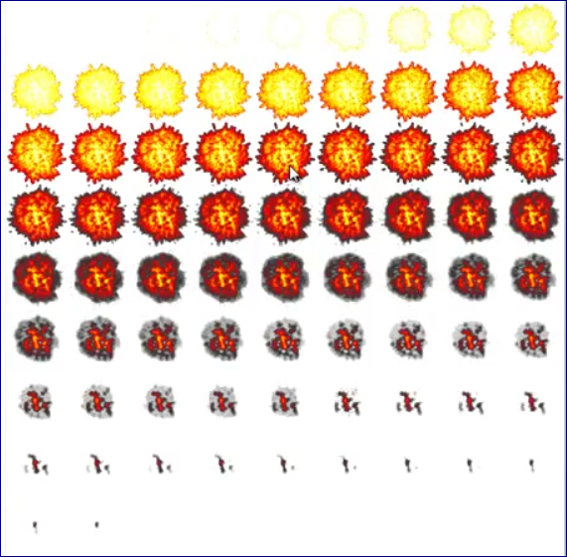

**RiceRocks (8:43)**

<http://www.codeskulptor.org/#examples-ricerocks_template.py>